

**SAVEETHA SCHOOL OF ENGINEERIING DEPARTMENT OF COMPUTER SCIENCE AND ENGINEERING**

# CSA15 – CLOUD COMPUTING AND BIG DATA ANALYTICS LABORATORY

INDEX

|  |  |  |  |  |
| --- | --- | --- | --- | --- |
| **S.N O** | **DATE** | **EXPERIMENT NAME** | **MARK S** | **SIGN** |
| 1. |  | Create a simple cloud software application and provide it as a service using any Cloud Service Provider to demonstrate  Software as a Service (SaaS). |  |  |
| 2. |  | Create a Virtual Machine with 1 vCPU, 2GB RAM and 15GB storage disk using a Type 2 Virtualization Software |  |  |
| 3. |  | Create a Virtual Hard Disk and allocate the storage using VM ware Workstation |  |  |
| 4. |  | Create a Snapshot and Cloning of a VM and Test it by loading the Previous Version/Cloned VM |  |  |
| 5. |  | Demonstrate Infrastructure as a Service (IaaS) by Creating a Virtual Machine using a Public Cloud Service Provider (Azure/GCP/AWS), configure with minimum CPU, RAM, and Storage and Launch the VM image. |  |  |
| 6. |  | Create a Simple Web Application using Java or Python and host it in any Public Cloud Service Provider  (Azure/GCP/AWS) to demonstrate Platform as a Service (PaaS) |  |  |
| 7. |  | Create a Storage service using any Public Cloud Service  Provider (Azure/GCP/AWS) and check the public accessibility of the stored file to demonstrate Storage as a Service |  |  |
| 8. |  | Create a SQL storage service and perform a basic query  using any Public Cloud Service Provider (Azure/GCP/AWS) to demonstrate Database as a Service (DaaS) |  |  |
| 9. |  | Perform the basic configuration setup for Installing Hadoop  2.x like Creating the HDUSER and SSH localhost |  |  |
| 10. |  | Install Hadoop 2.x and configure the Name Node and Data Node. |  |  |
| 11. |  | Launch the Hadoop 2.x and perform MapReduce Program for a Word Count problem |  |  |

**EXP NO 1: CREATE A SIMPLE CLOUD SOFTWARE APPLICATION AND PROVIDE IT AS A SERVICE USING ANY CLOUD SERVICE PROVIDER TO DEMONSTRATE SOFTWARE AS A SERVICE (SAAS).**

**DATE:**

**AIM:**

**PROCEDURE:**

**IMPLEMENTATION: STEP1: GOTO ZOHO.COM**

**STEP 2: LOGINTOTHE ZOHO.COM**

**STEP 3: SELECT ONE APPLICATION**



**STEP 4: ENTER APPLICATION NAME**

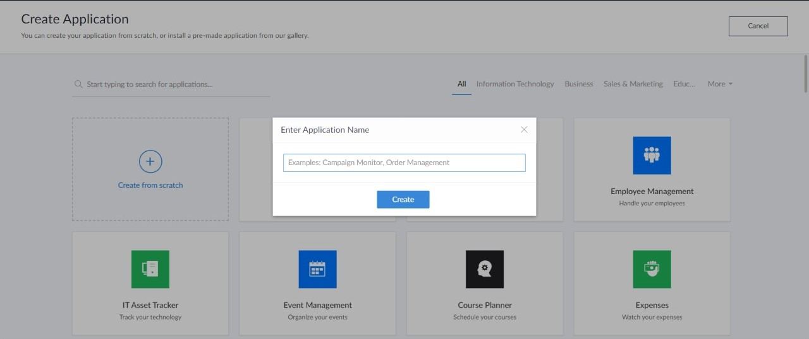

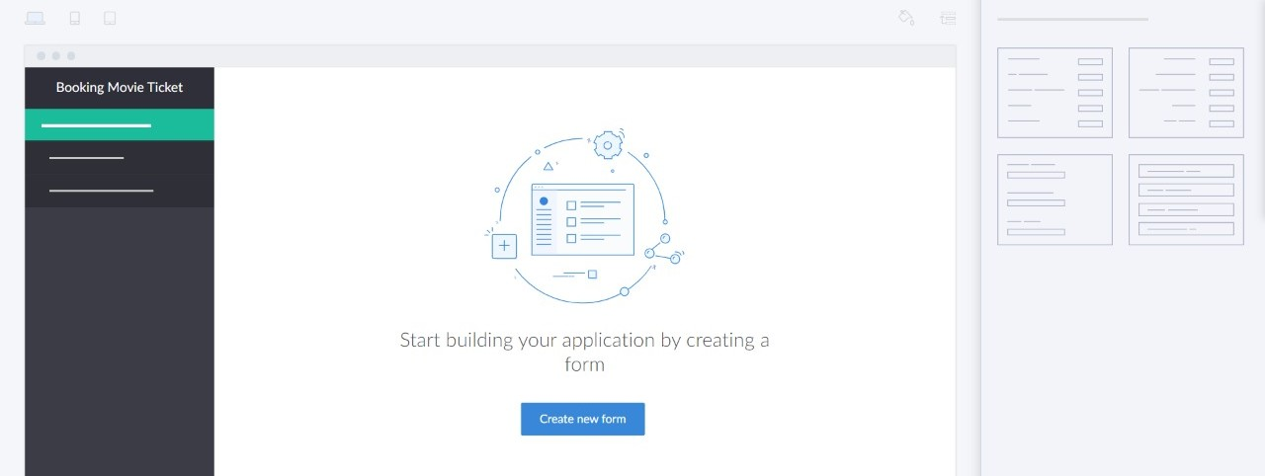**STEP 5: CREATED NEW APPLICATION**

**STEP 6: SELECT ONE FORM**



**STEP 7: THE SOFTWARE HASE BEEN CREATED.**

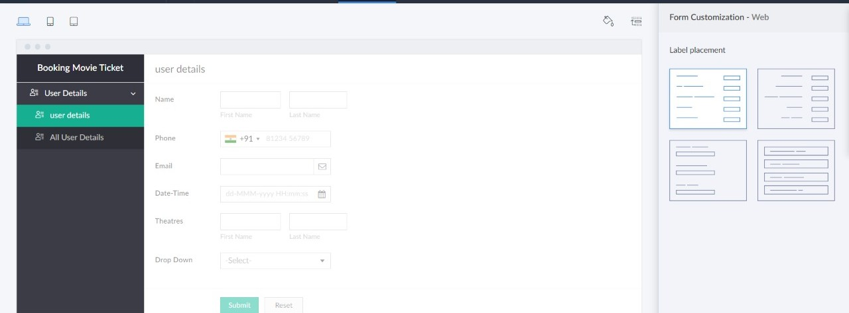

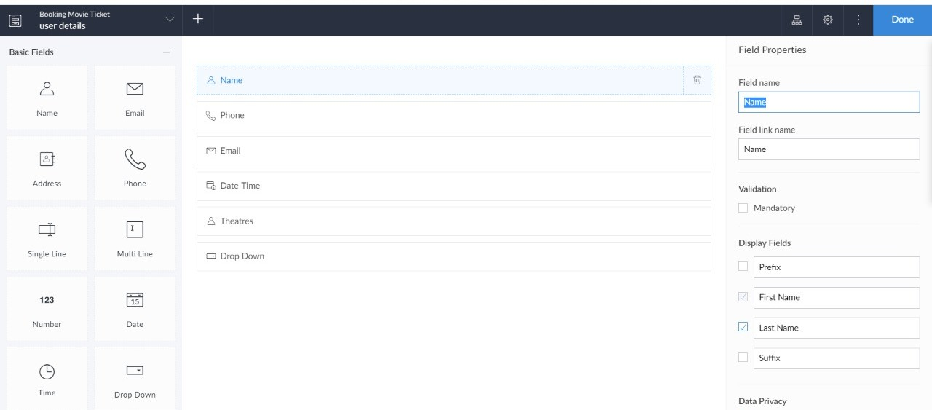

**RESULT:**

**EXPNO 2: CREATE A VIRTUAL MACHINE WITH 1 VCPU, 2GB RAM AND 15GB STORAGE DISK USING A TYPE 2 VIRTUALIZATION SOFTWARE**

**DATE:**

**AIM:**

**PROCEDURE:**

**IMPLEMENTATION:**

**STEP 1:**

**DOWLOAD VMWARE WORKSTATION AND INSTALLED AS TYPE 2 HYPERVISOR**

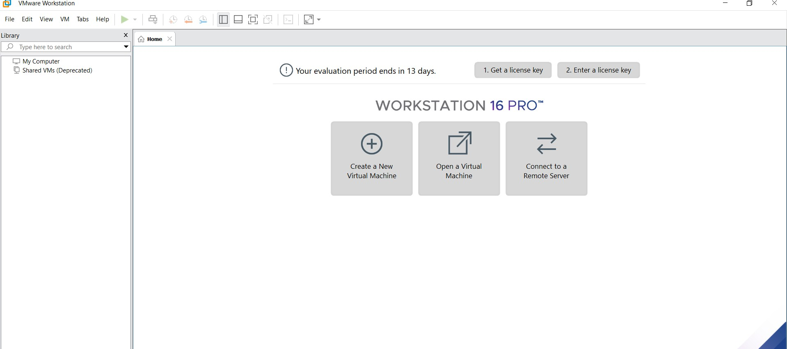

**STEP2: DOWLOAD UBUNTU OR TINY OS AS ISO IMAGE FILE**

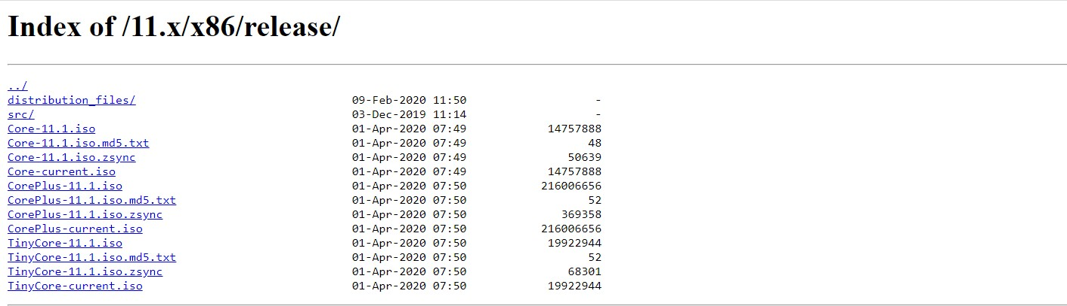

**STEP 3: IN VMWARE WORKSTATION->CREATE NEW VM**



**STEP 4: DO THE BASIC CONFIGURATION SETTINGS.**

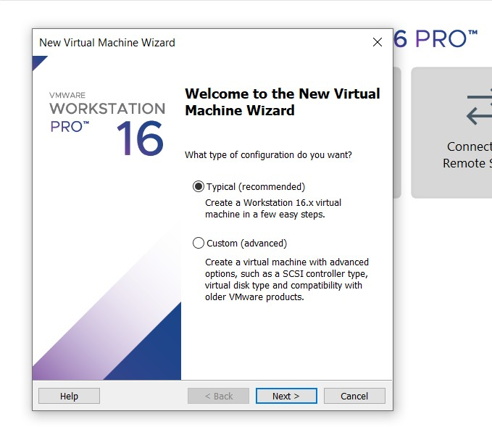

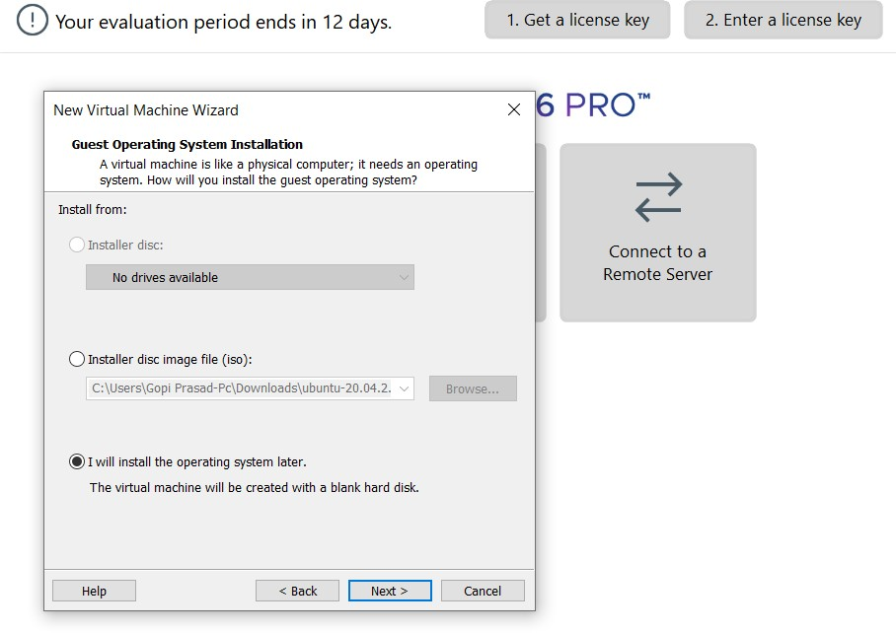

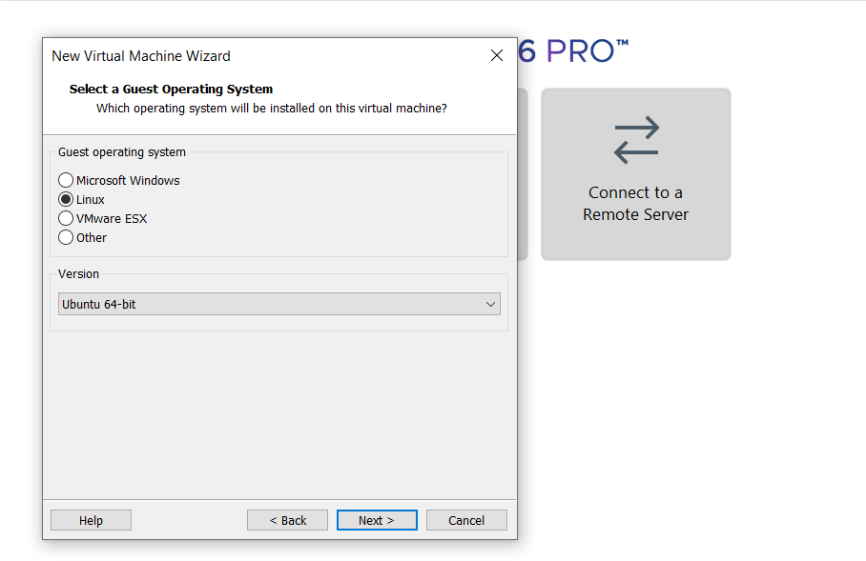

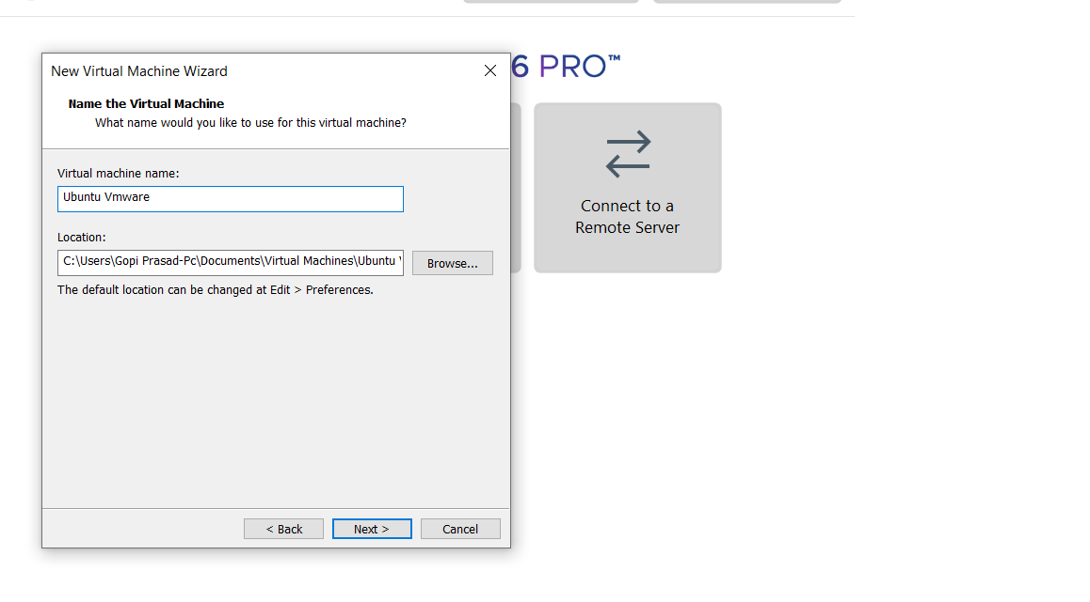

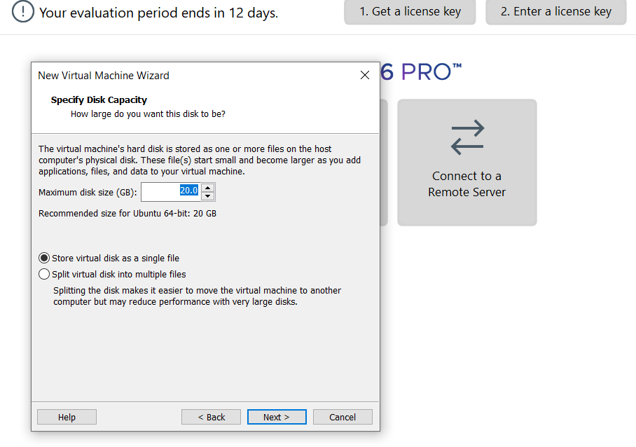



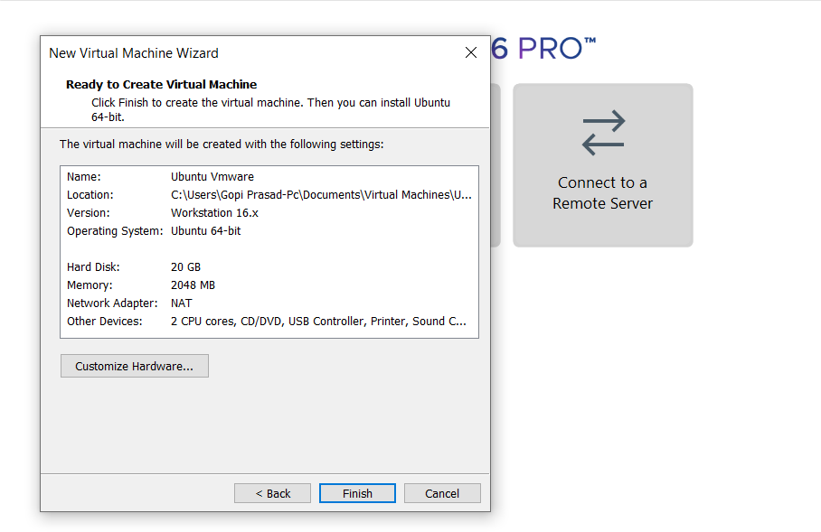

**STEP 4: CREATED TINYOS VIRTUAL MACHINE**

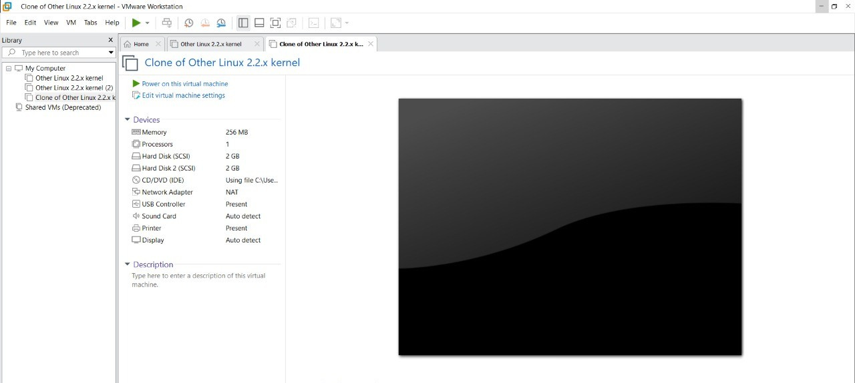

**STEP 5: LAUNCH THE VM**

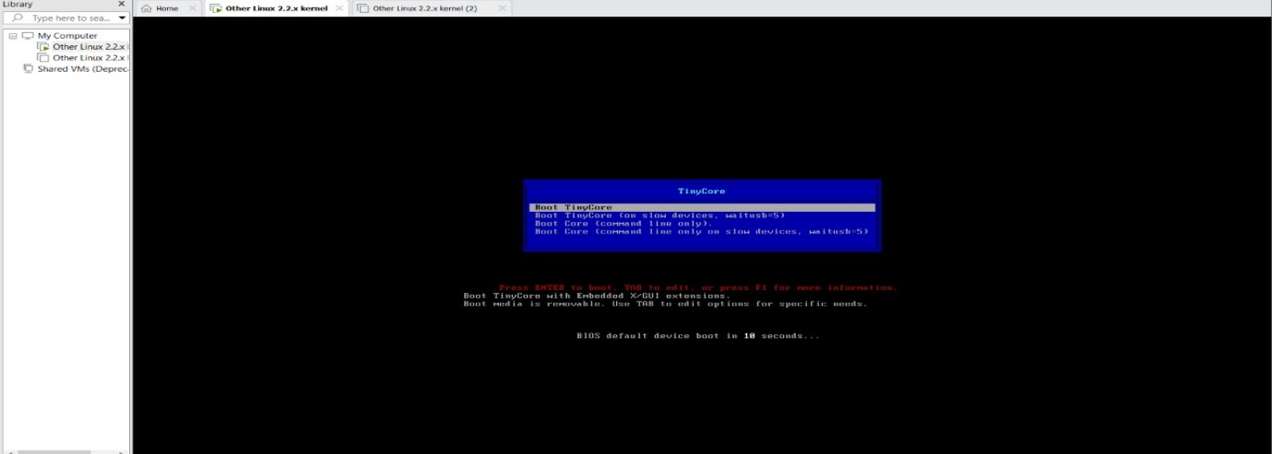

**RESULT**

**EXP 3: CREATE A VIRTUAL HARD DISK AND ALLOCATE THE STORAGE USING VM WARE WORKSTATION**

**DATE:**

**AIM:**

**PROCEDURE:**

**IMPLEMENTATION:**

**STEP 1:**

**GOTO VM WARE WORKSTATION**



**STEP2: RIGHT CLICK THE VM AND GOTO THE SETTINGS**

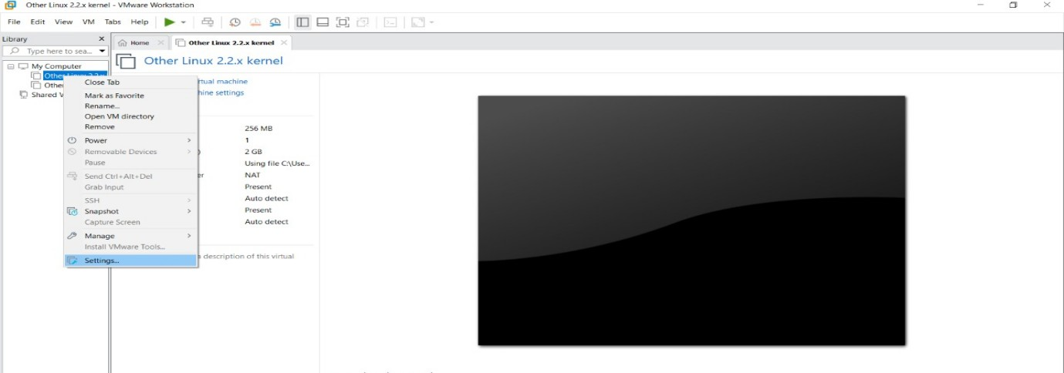

**STEP 3: ADD HARDWARE WIZARD AND SELECT SCSI AND CLICK NEXT**

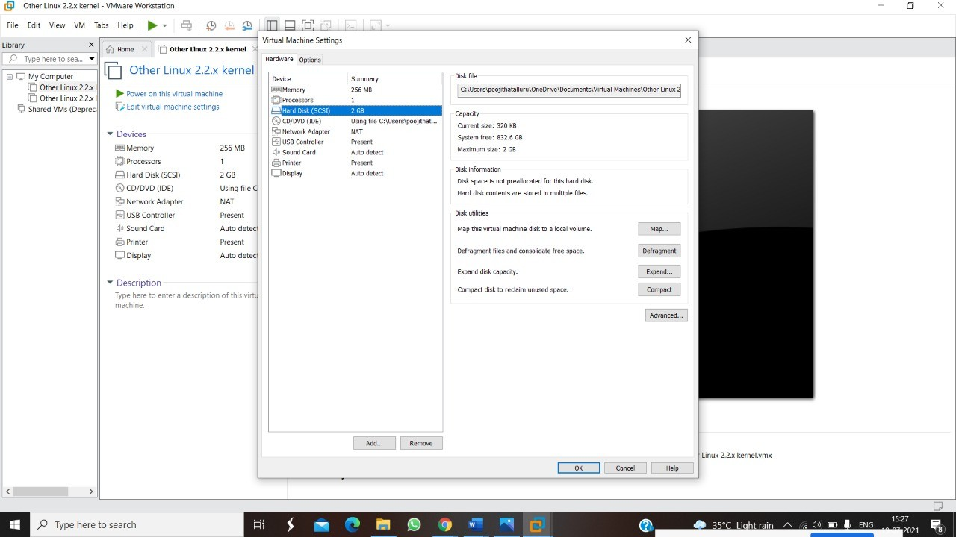

**STEP 4: CREATE NEW VIRTUAL DISK**

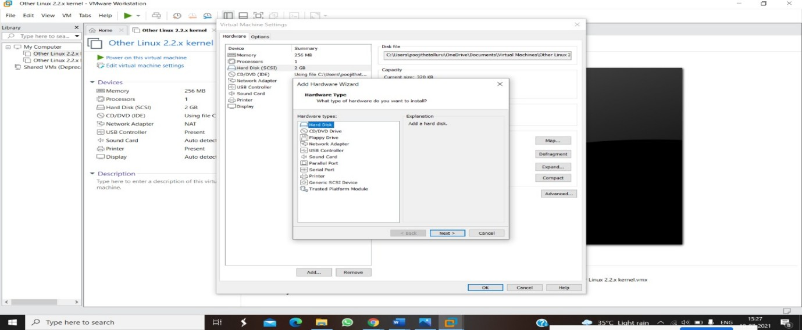

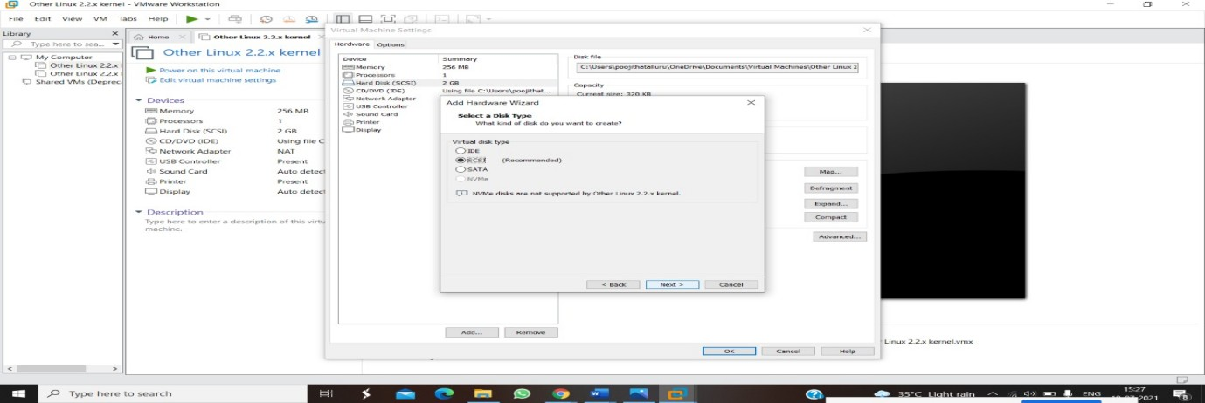

**STEP 5: SELCT THE DISK SIZE AS 2.0. AND SELCT SPLIT VIRTUAL DISK INTO MULTIFILES.**

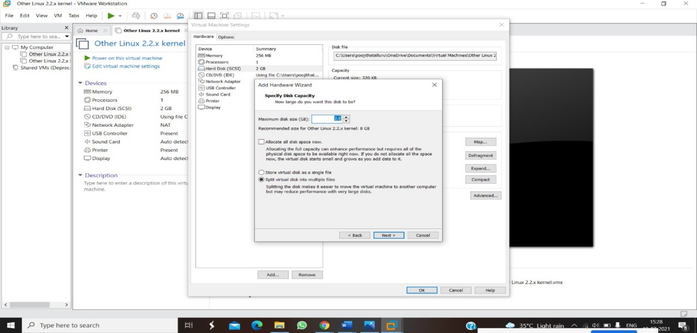

**STEP 6: GIVE NAME AND CLICK THE FINISH**

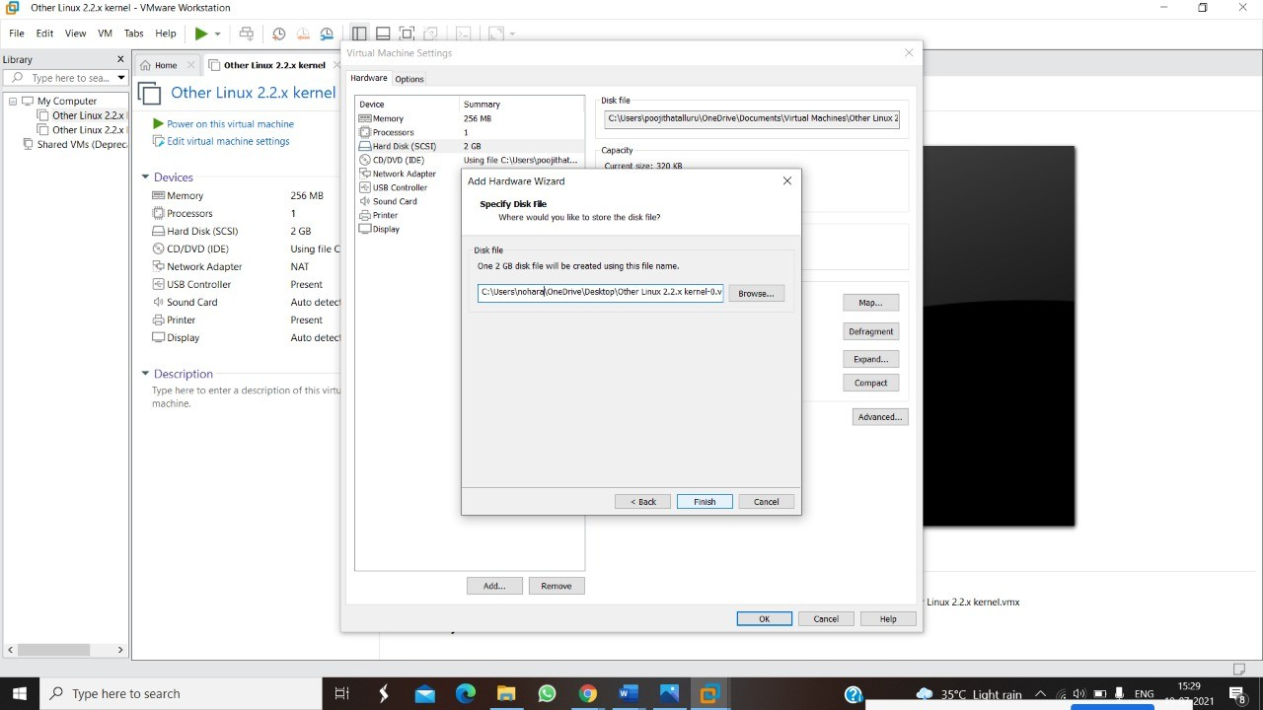

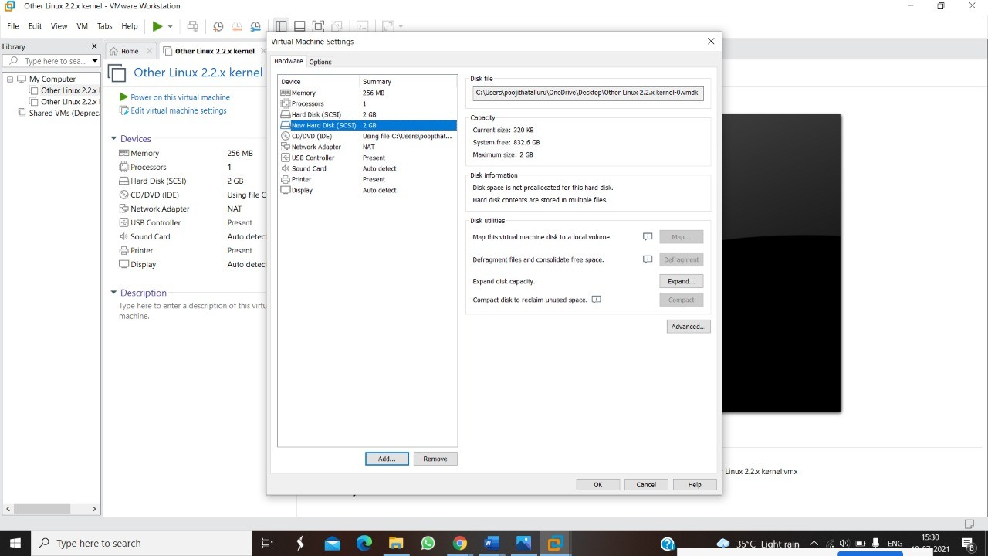

**RESULT:**

**EXPNO 4: CREATE A SNAPSHOT AND CLONING OF A VM AND TEST IT BY LOADING THE PREVIOUS VERSION/CLONED VM**

**DATE:**

**AIM:**

**PROCEDURE:**

**IMPLEMENTATION:**

**STEP 1: GOTO VMWARE WORKSTATION**

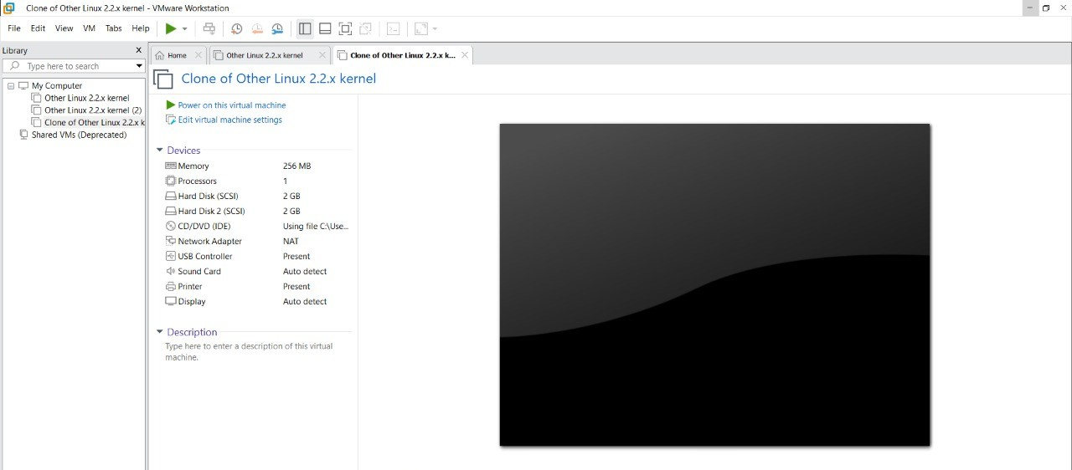

**STEP 2: CREATE FILES ON DESKTOP**



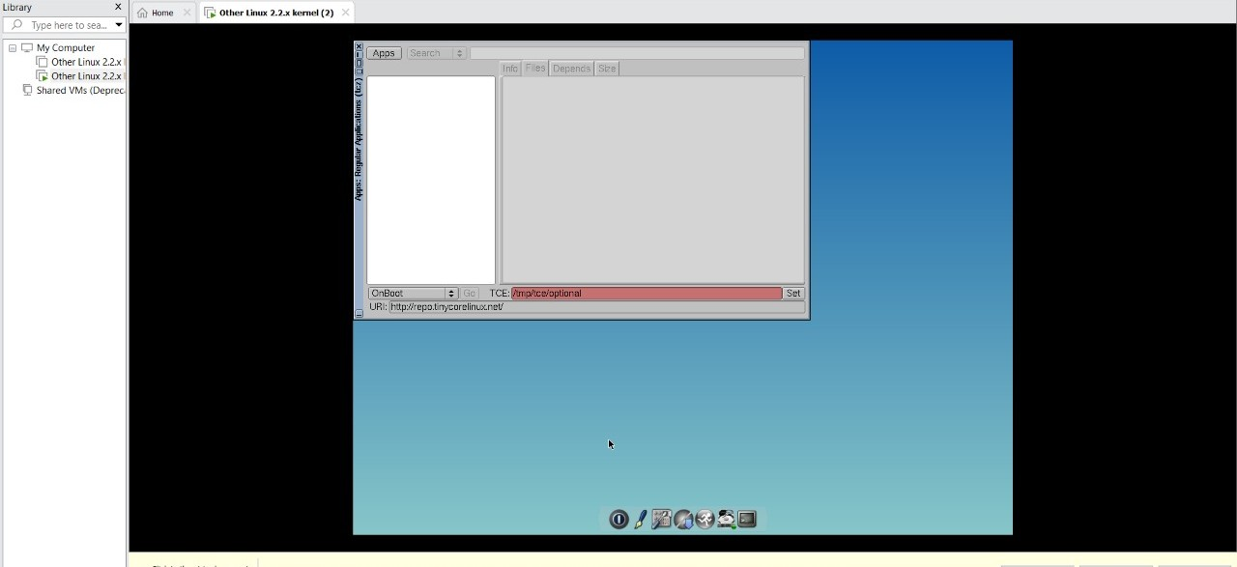

**STEP 2: CLICK ON VM AND SELECTS SNAPSHOT-> TAKE SNAPSHOT.**

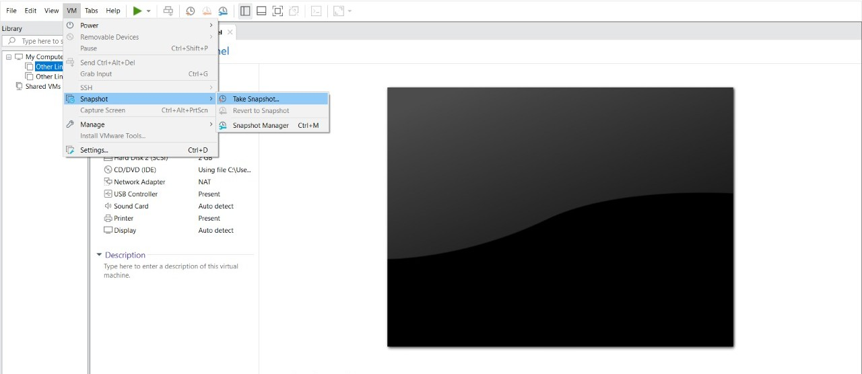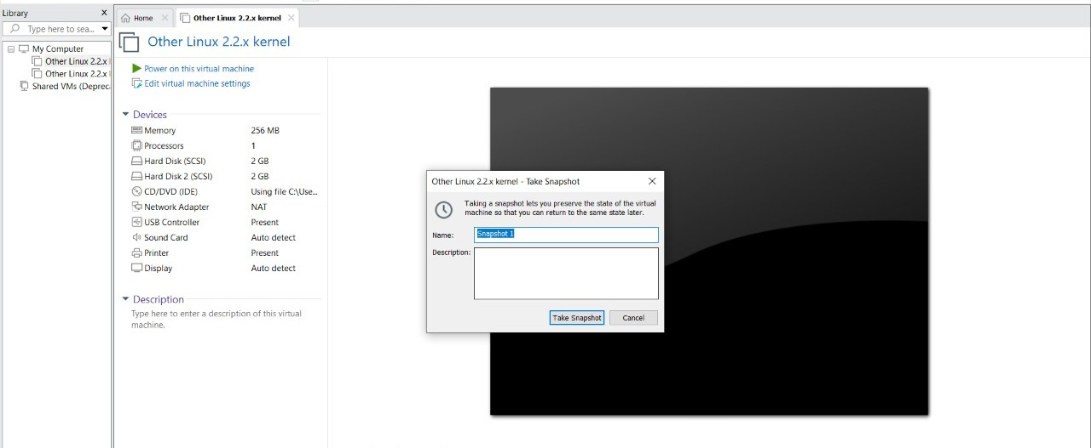

**STEP 4: SNAPSHOT IS BEING DONE**

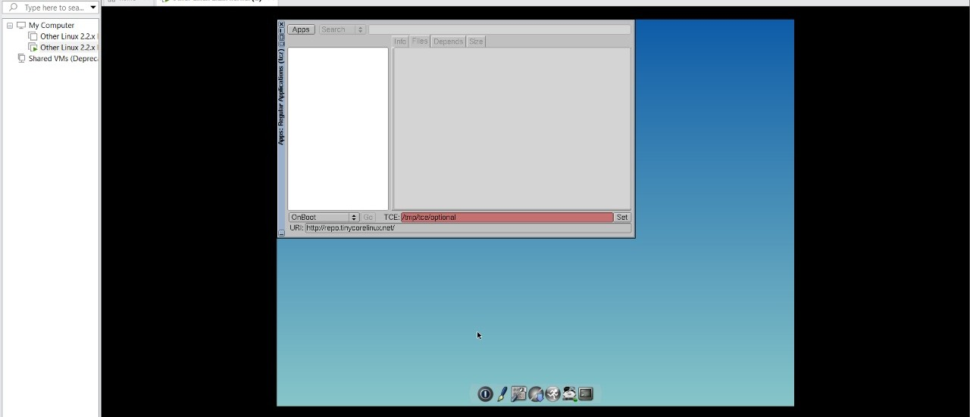

**CLONING OF A VM**

**STEP 1: GO TO VM AND GOTO MANAGE AND CLICK CLONE**

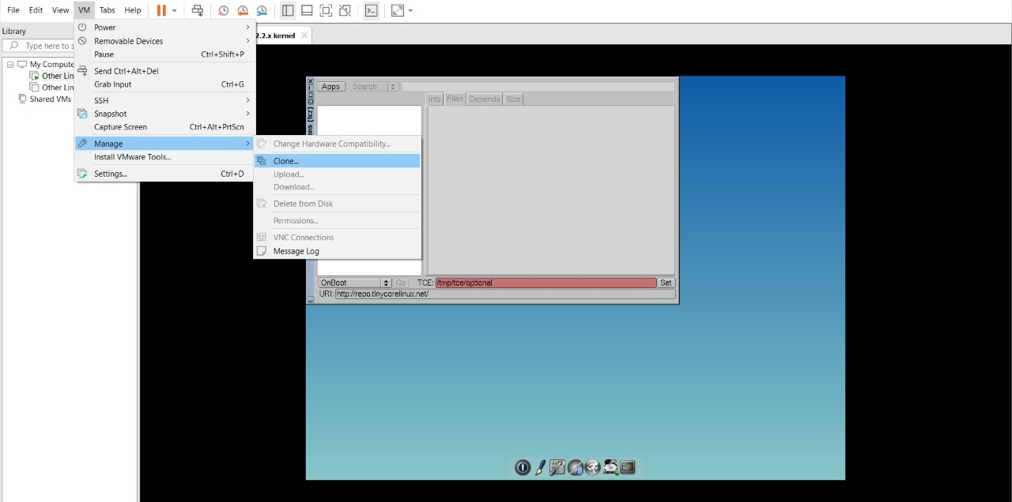

**STEP 2: CLICK CLONE**

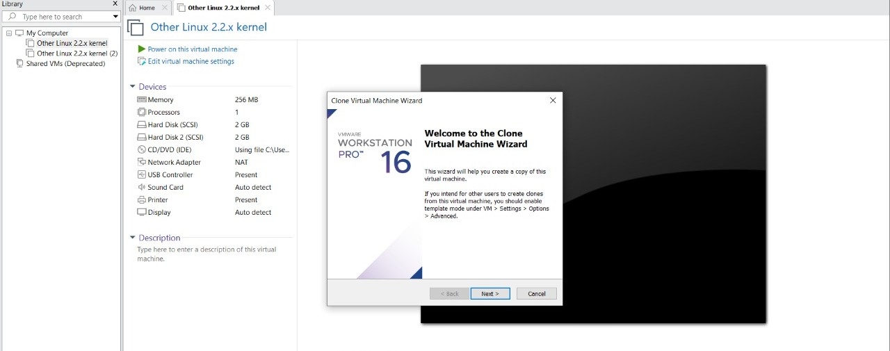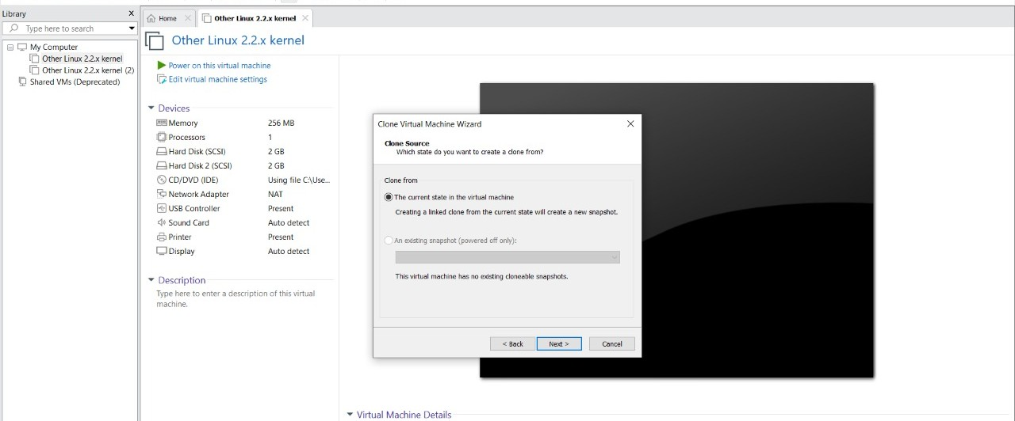

**STEP 3: SELECT THE FULL CLONE**

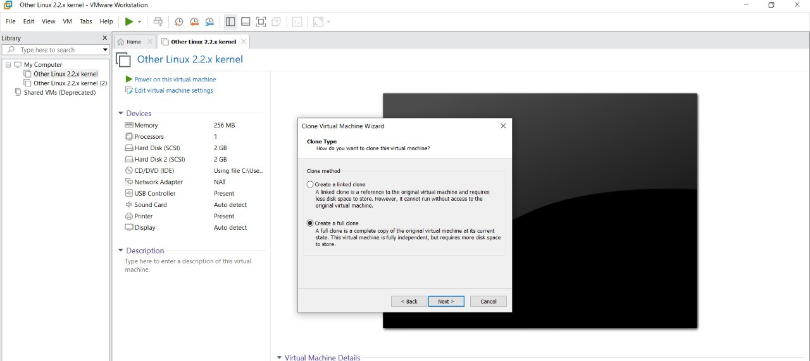

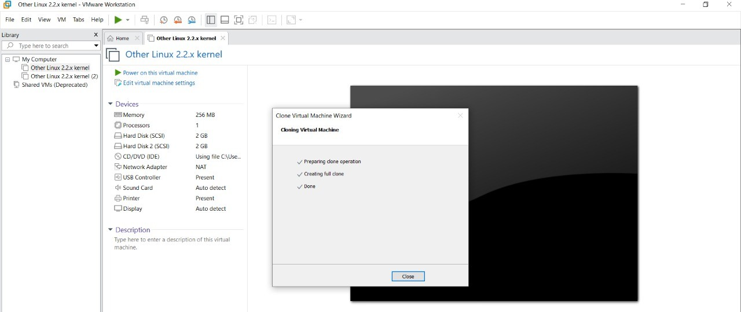

**STEP 4: AFTER CLONE AGAIN OR VM IS OPENED.**

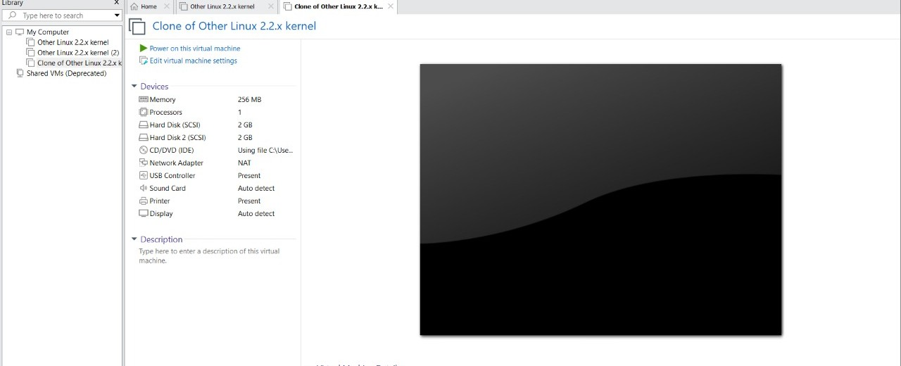

**RESULT:**

1. **DEMONSTRATE INFRASTRUCTURE AS A SERVICE(IAAS) BY CREATING A VIRTUAL MACHINE USING A PUBLIC CLOUD SERVICE PROVIDER(AZURE/GCP/AWS) CONFIGURE WITH MINIMUM CPU,RAM AND STORAGE AND LAUNCH THE VM IMAGE.**

**AIM:**

**Procedure:**

**Implementation:**

**STEP1:CREATE AN ACCOUNT IN MICROSOFT AZURE.**

**STEP2: GOTO RESOURCE GROUP AND CREATE A RESOURCE GROUP.**

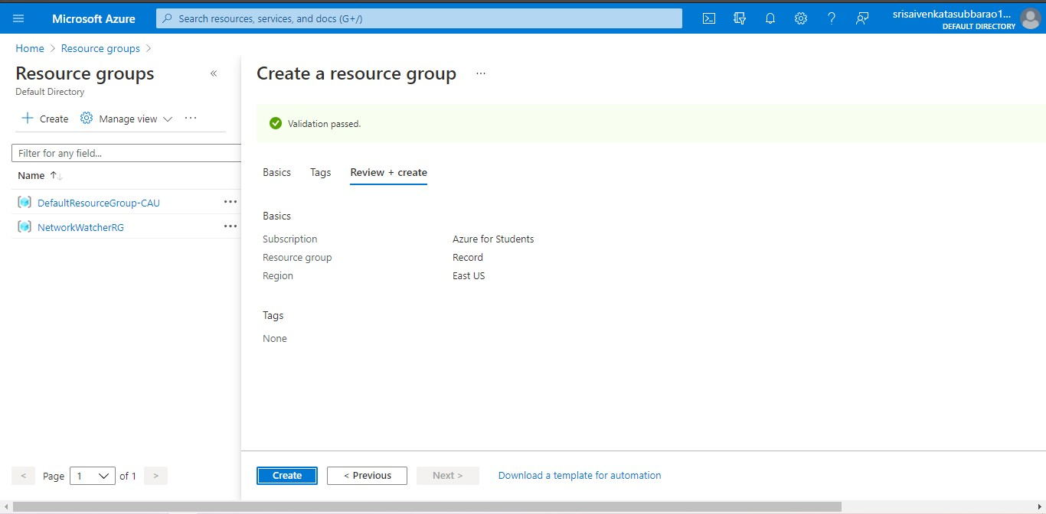

**STEP3: GIVE NECESSARY THINGS FOR RESOURCE GROUP.**

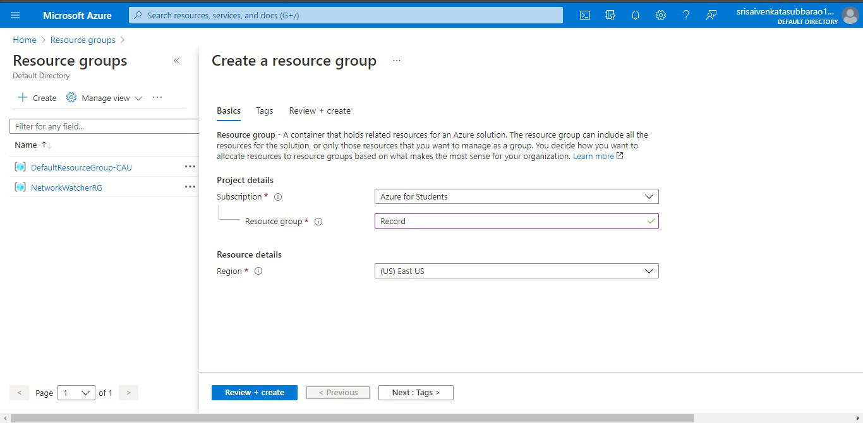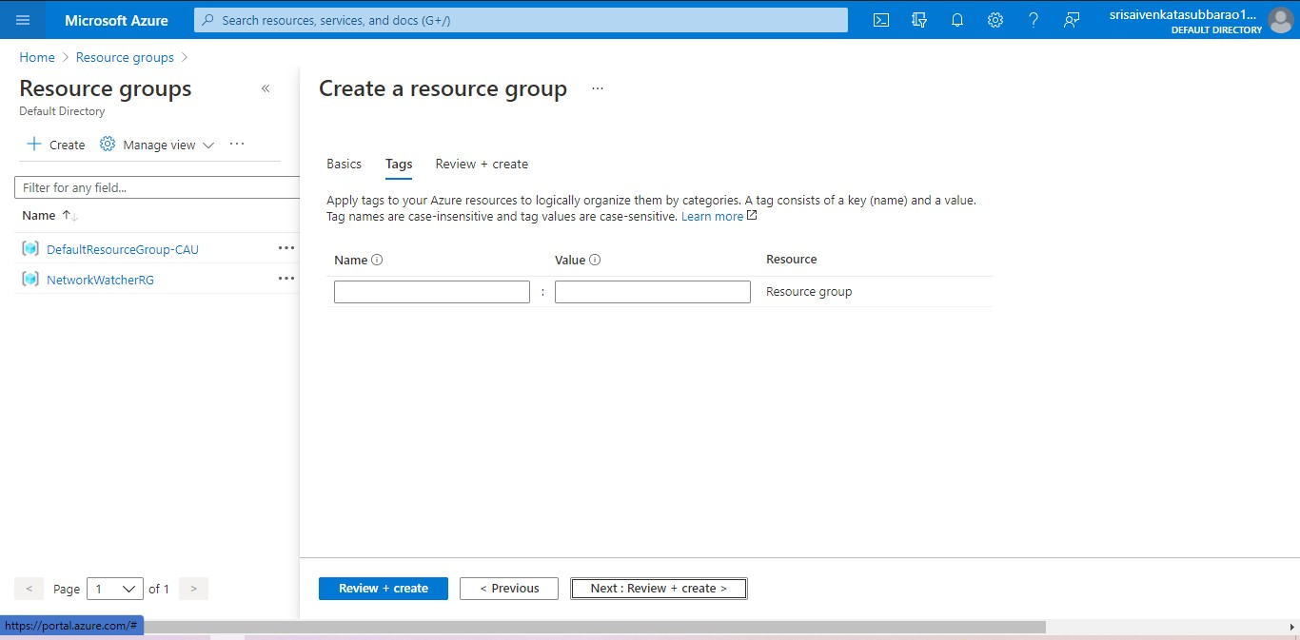

**STEP4: CREATE A VIRTUAL NETWORK FOR TO CREATE A VIRTUAL MACHINE .**

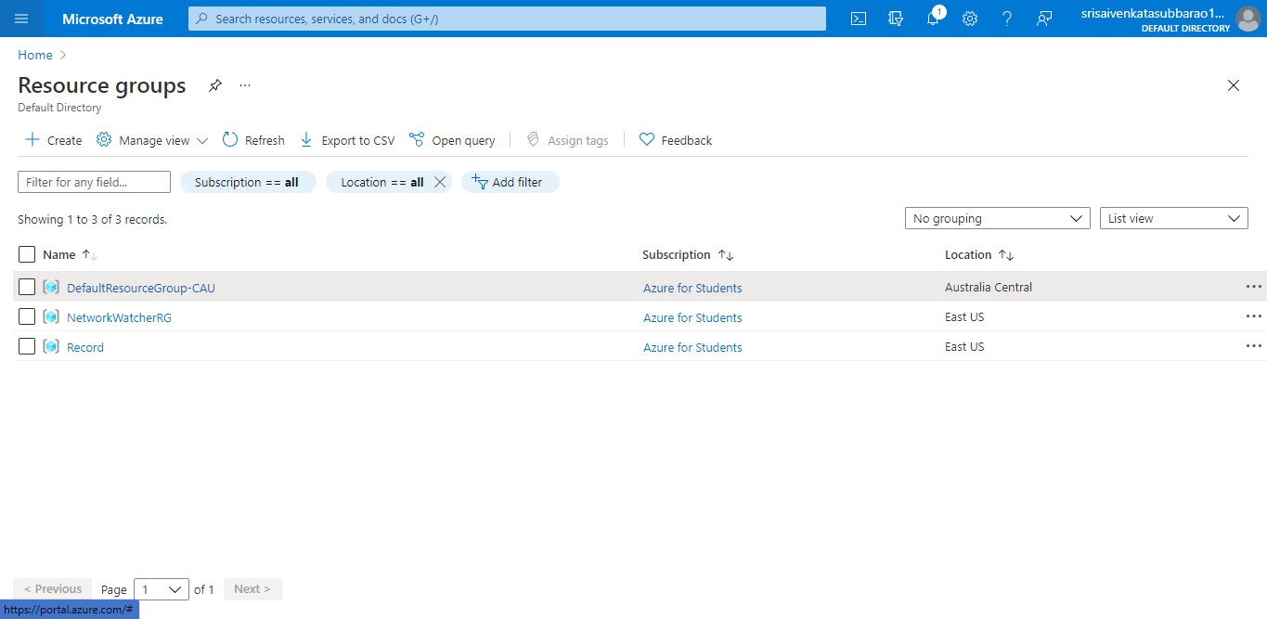

**STEP5: NOW CREATE A VIRTUAL MACHINE WITH UR IP ADDRESS AN USERNAME AND PASSWORD FOR YOUR VIRTUAL MACINE.**

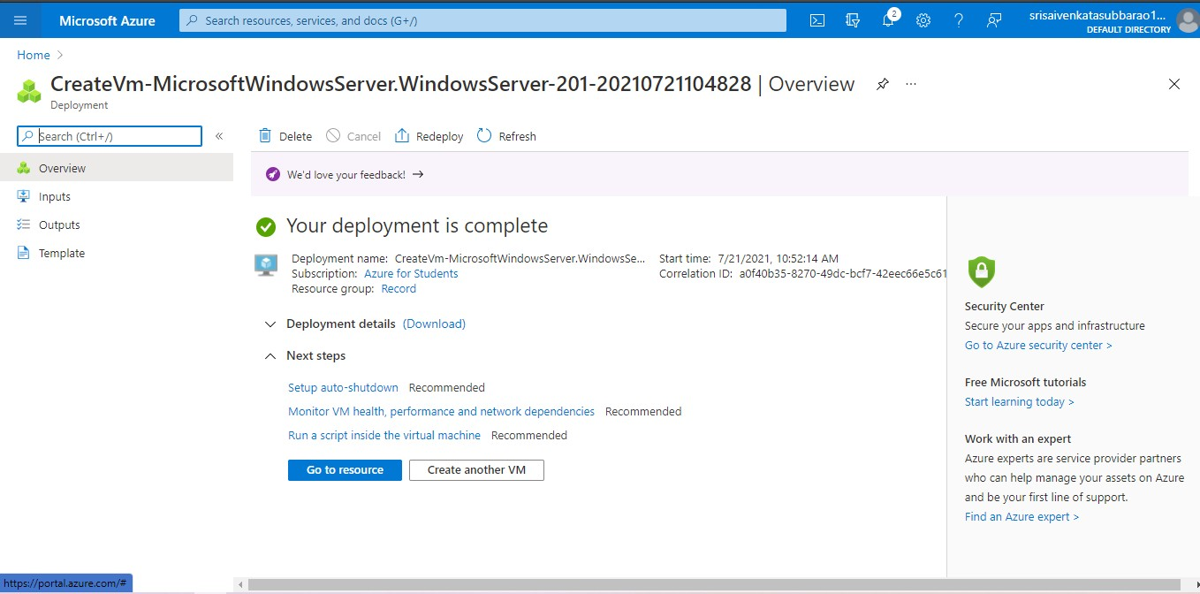**STEP6: AND YOUR VIRTUAL MACHINE IS DEPLOYED.**

**STEP7: NOW CONNECT THE VIRTUAL MACHINE AND DOWNLOAD THE RDP FILE TO OPEN YOUR WINDOWS VIRTUAL MACHINE.**

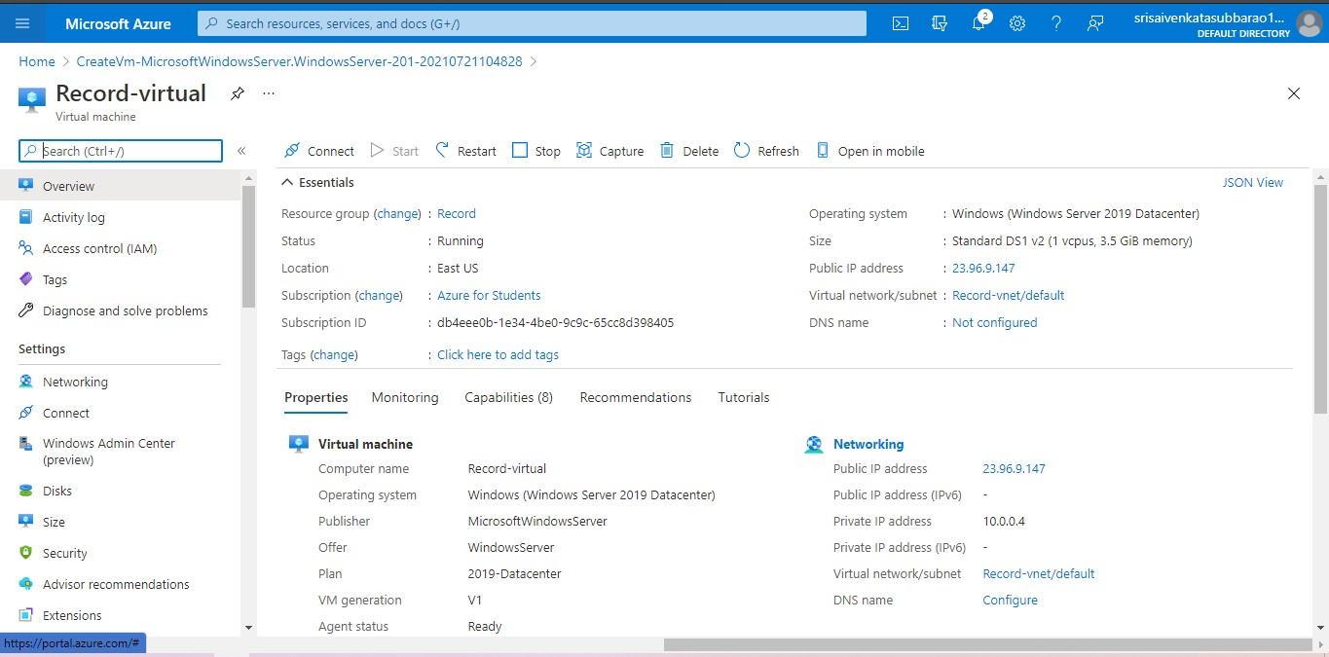

**STEP8: CREATED A NEW WINDOWS VIRTUAL MACHINE.**



**RESULT:**

1. **CREATE A SIMPLE WEB SITE USING ANY PUBLIC CLOUD SERVICE PROVIDER (AZURE/GCP/AWS) AND CHECK THE PUBLIC ACCESSIBILITY OF THE STORED FILE TO DEMONSTRATE STORAGE AS A SERVICE**

**AIM:**

**Procedure:**

**IMPLEMENTATION:**

**STEP1: FIRSTLY GO TO APPSERVICE TO CREATE AN WEBAPP.**

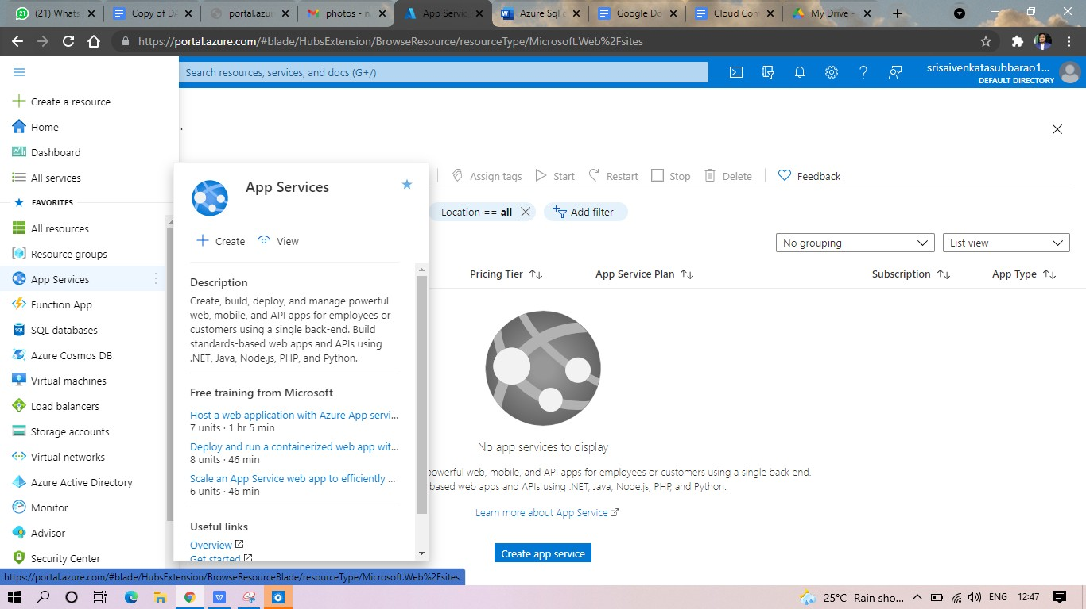

**STEP2: ENTER THE RESOURCE GROUP AND WEBAPP NAME AND REGION AND SELECT THE LINUX OS.**

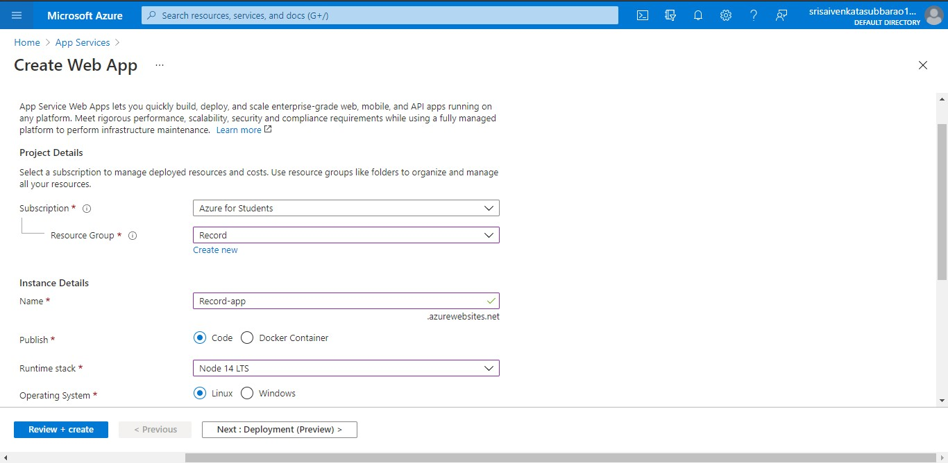

**STEP3: AFTER ENTER THE ALL THE NECESSARY THINGS CLICK THE REVIEW AND CREATE AND CLICK THE CREATE THE WEB APP.**

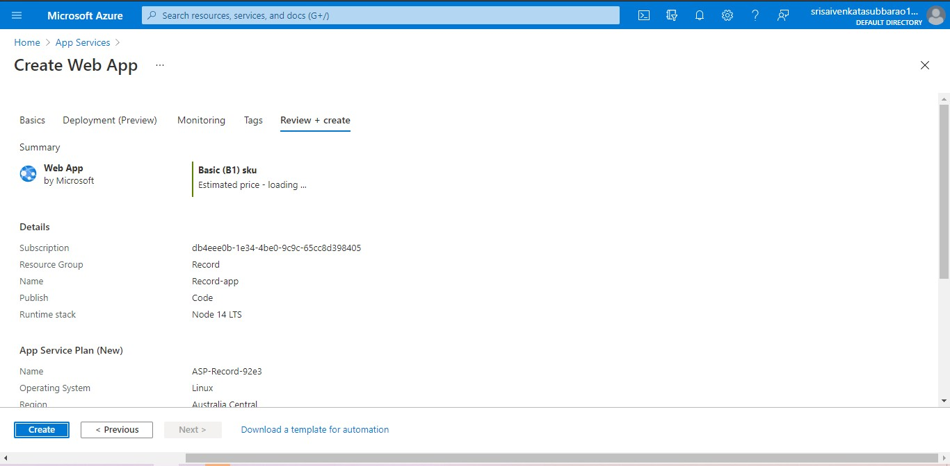

**STEP4: AND OUR DEPLOYMENT IS COMPLETED.**

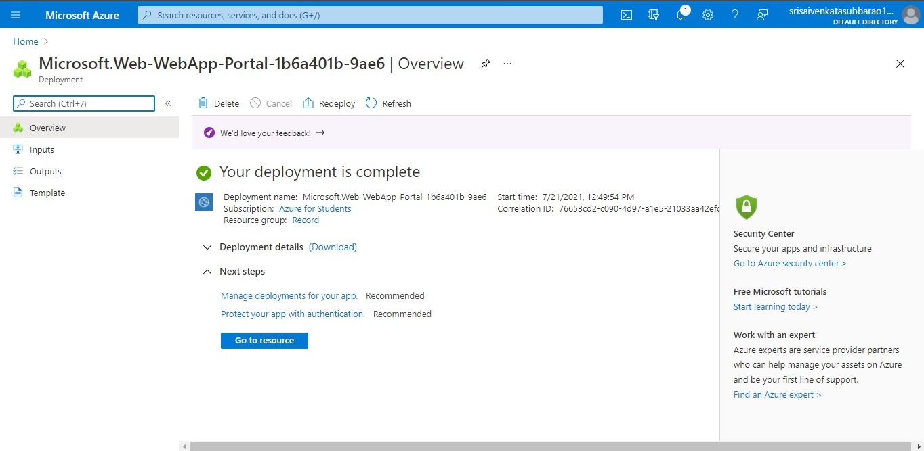

**STEP5: GOTO WEBSITE URL LINK.**

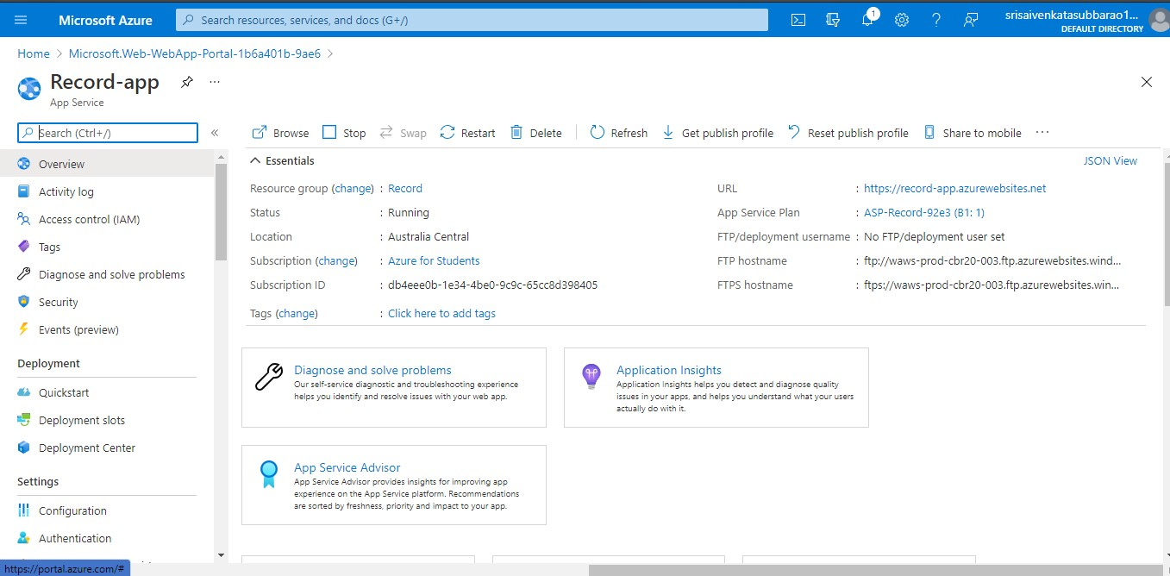

**STEP6: THIS IS OUR WEBAPP SERVICE.**

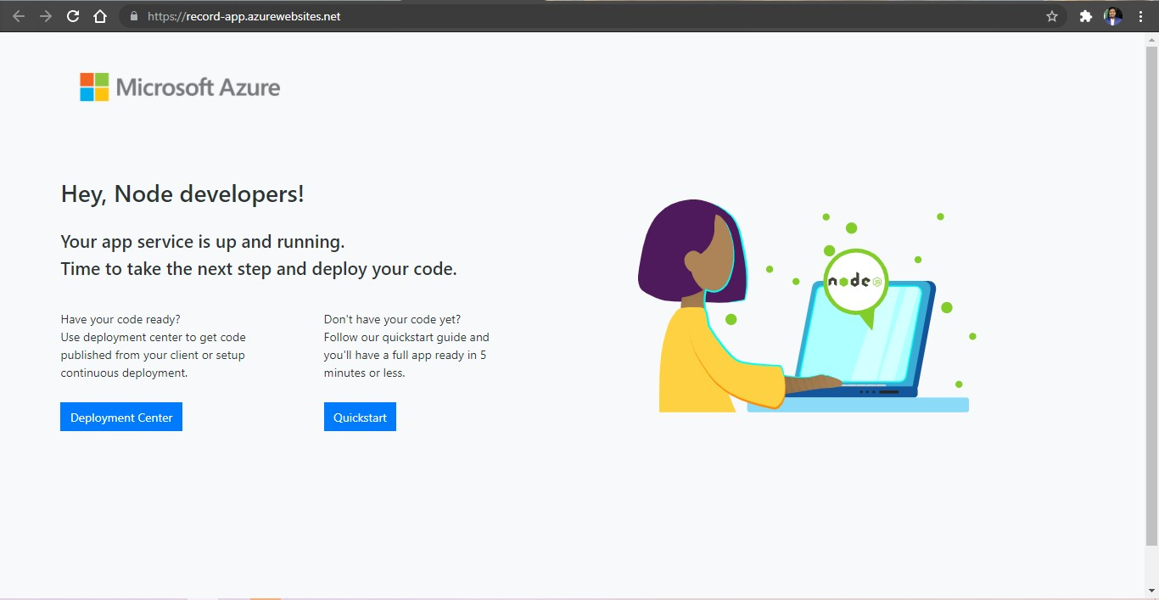

1. **CREATE A STORAGE SERVICE USING ANY PUBLIC CLOUD SERVICE PROVIDER (AZURE/GCP/AWS) AND CHECK THE PUBLIC ACCESSIBILITY OF THE STORED FILE TO DEMONSTRATE STORAGE AS A SERVICE.**

**AIM:**

**PROCEDURE:**

**IMPLEMENTATION:**

**STEP1: OPEN AZURE AND GOTO STORAGE ACCOUNTS AND CREATE STOROAGE ACCOUNT**

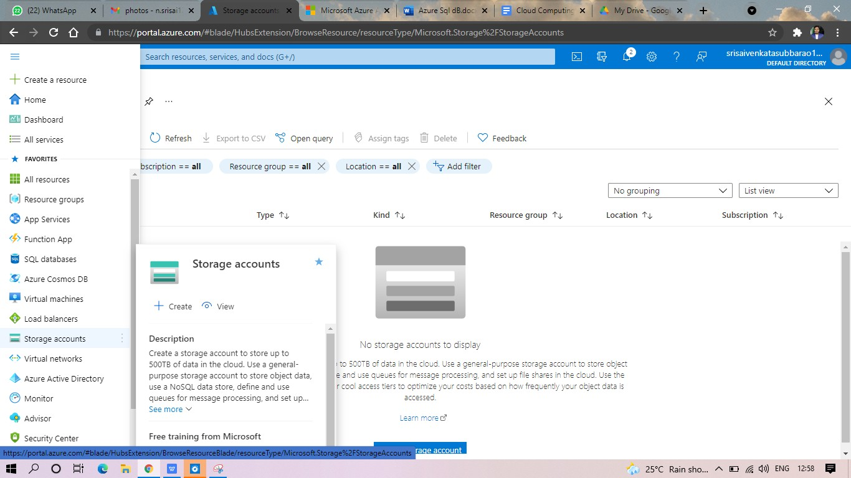

**STEP2: ENTER THE RESOURC GROUP AND AND STORAGE ACCOUNT NAME AND REVIEW AND CREATE AND CLICK TH CREATE AND YOUR STORAGE ACCOUNT WILL BE DEPLOYED SUCESSFULLY.**

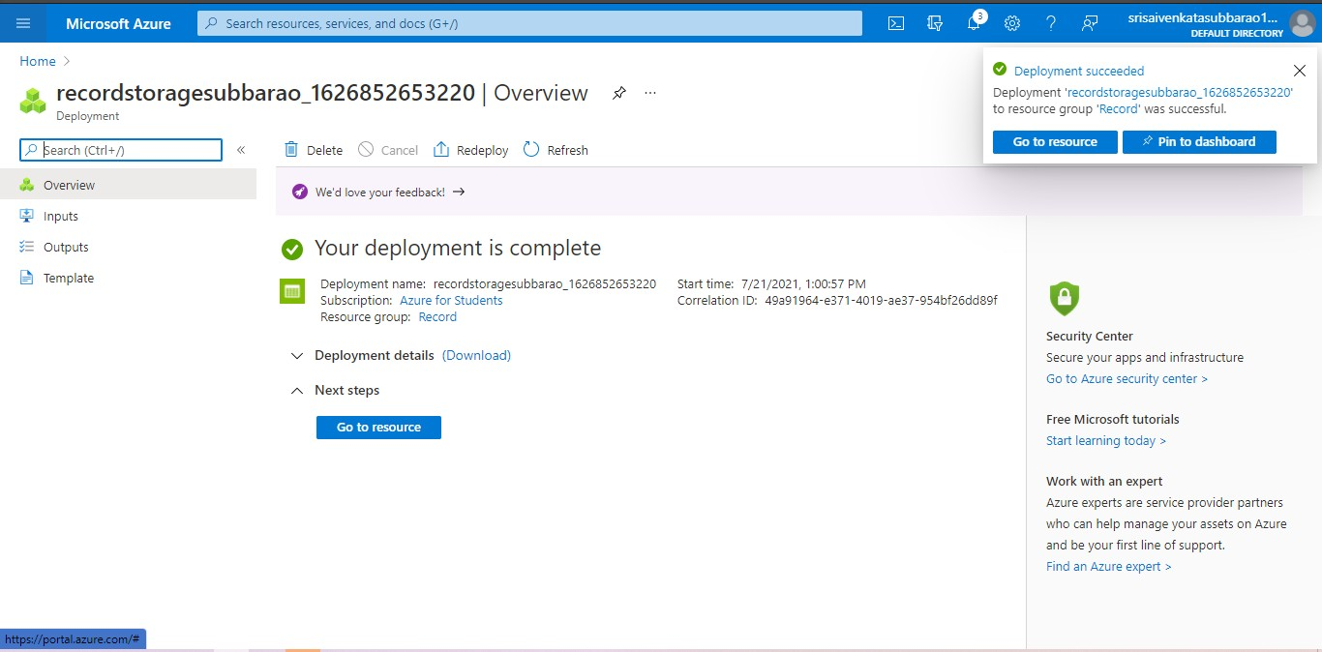

**STP3: AND OUR STORAGE ACCOUNT IS CREATED.**

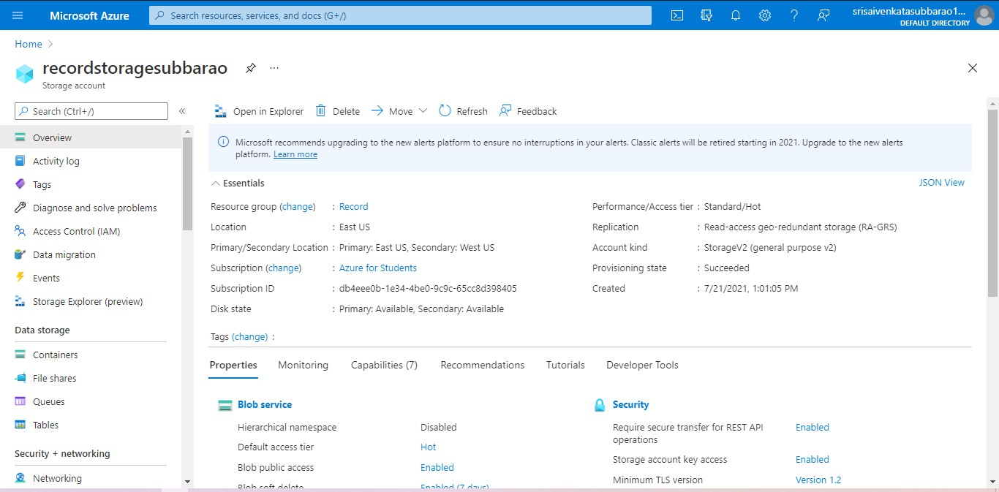

**STEP5: GOTO STATIC WEBSITE**

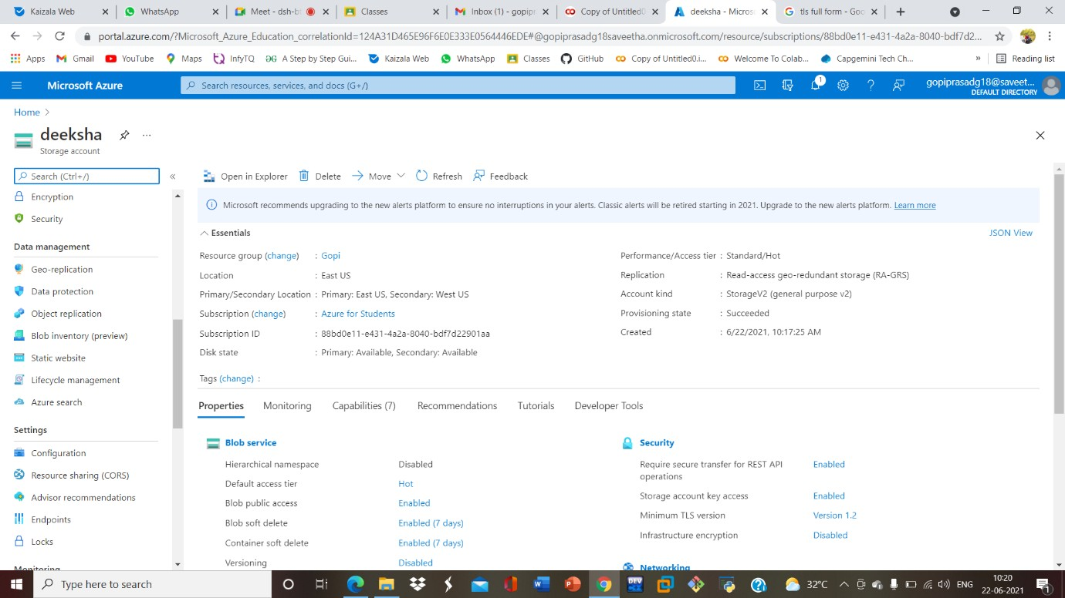

**STEP6: AND ENABLE AND ENTER YOUR INDEX AND ERROR HTML FILESNAMES.**

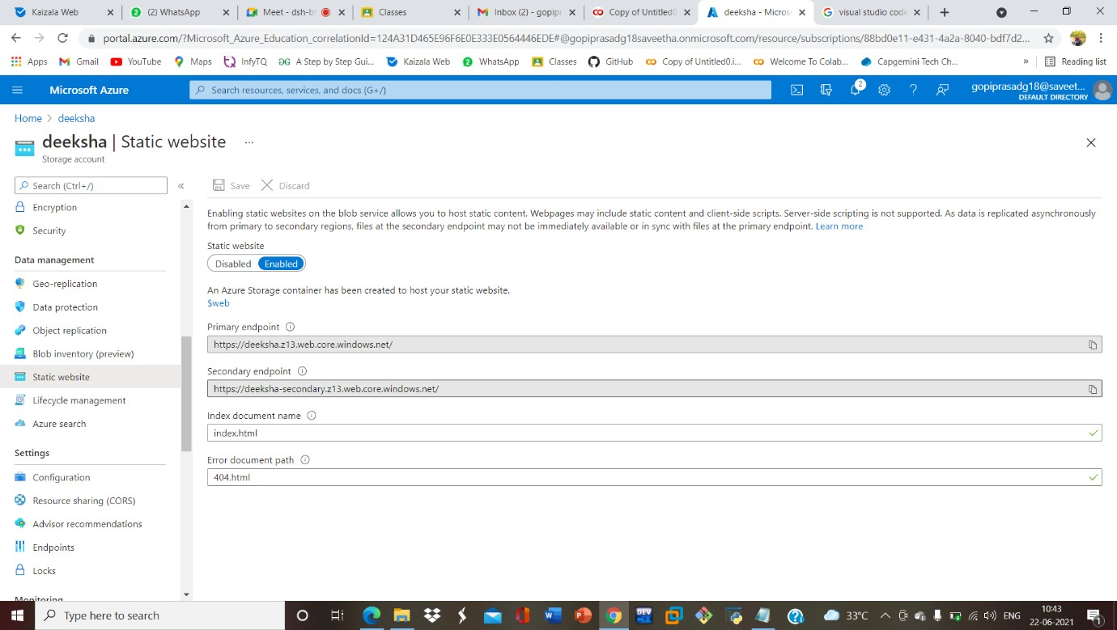

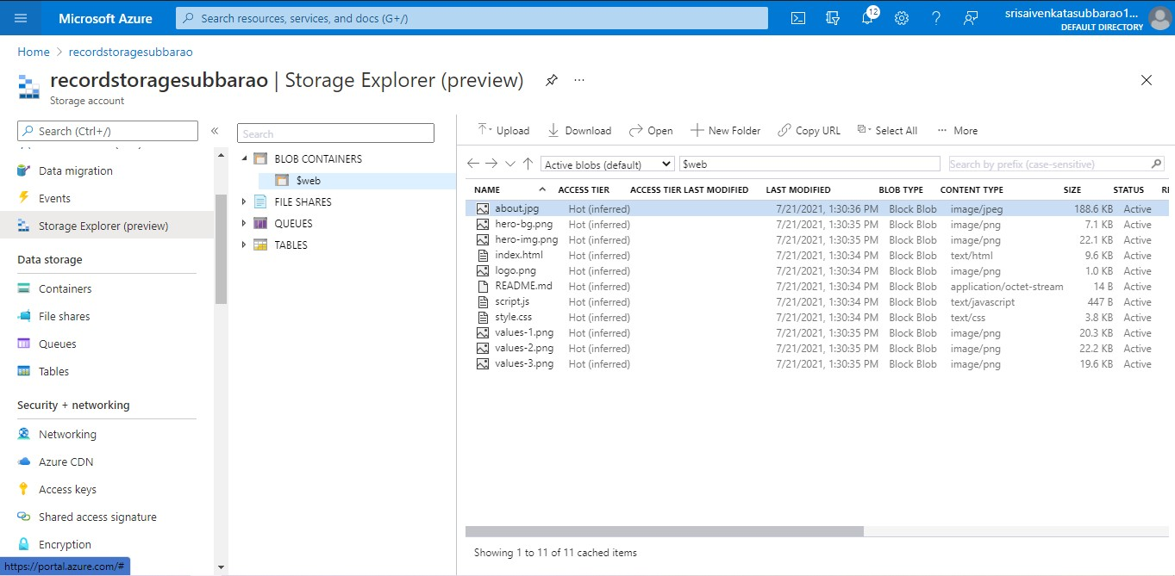**STEP7: AND GOTO STORAGE EXPLORR(REVIEW) AND AND GOTO BLOB CONTAINERS AND WEB AND UPLOAD THE TWO HTML FILES INIT**

**STEP8: AND AGAIN RETURN TO STATIC WEBSITE AND OPEN THE PRIMARY LINK AND YOUR WEB PAGE IS CREATED**



**RESULT:**

1. **CREATE A SQL STORAGE SERVICE AND PERFORM A BASIC QUERY USING ANY PUBLIC CLOUD SERVICE PROVIDER (AZURE/GCP/AWS) TO**

**DEMONSTRATE DATABASE AS A SERVICE (DAAS)**

**AIM:**

**PROCEDURE:**

**IMPLEMENTATION:**

**STEP1: GOTO AZURE AND GOTO SQLDATABASE.**

# STEP 02:- Now Create a Sql Databse

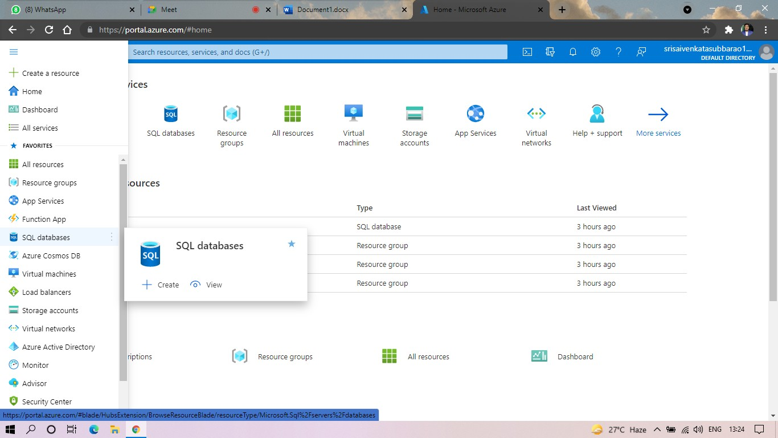

**STEP3: SELECT THE RESOURCE GROUP AND ENTER THE SERVERNAME THAT APPLICABLE.**

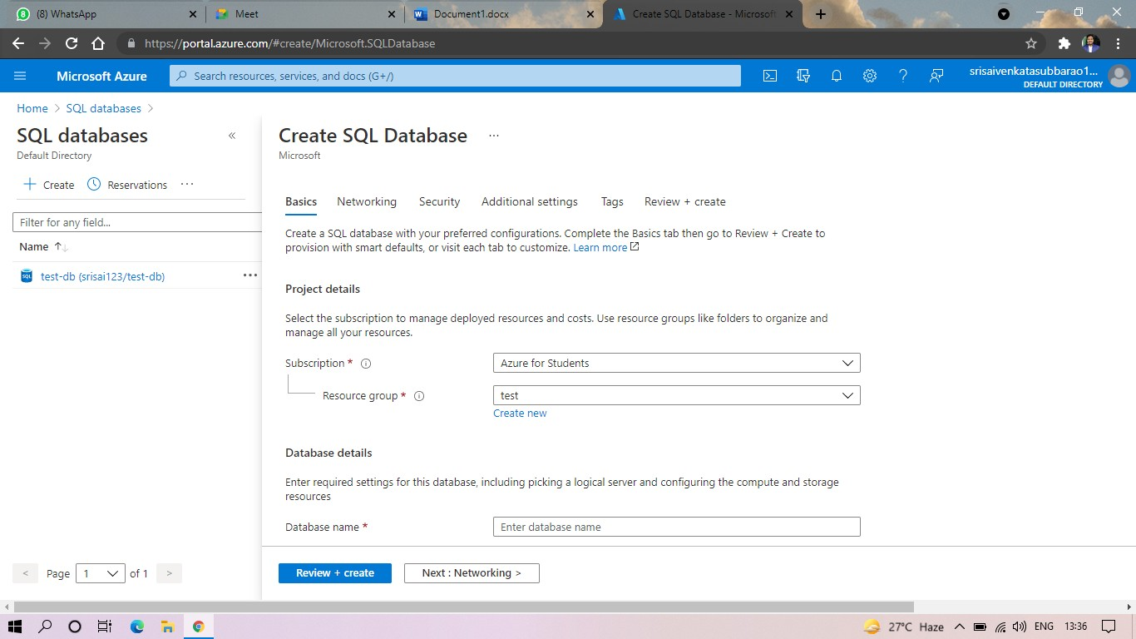

**STEP4: IN NETWORKING SELECT ALLOW AZURE SERVICES AND RESOURCES TO ACCESS THIS SERVER.**

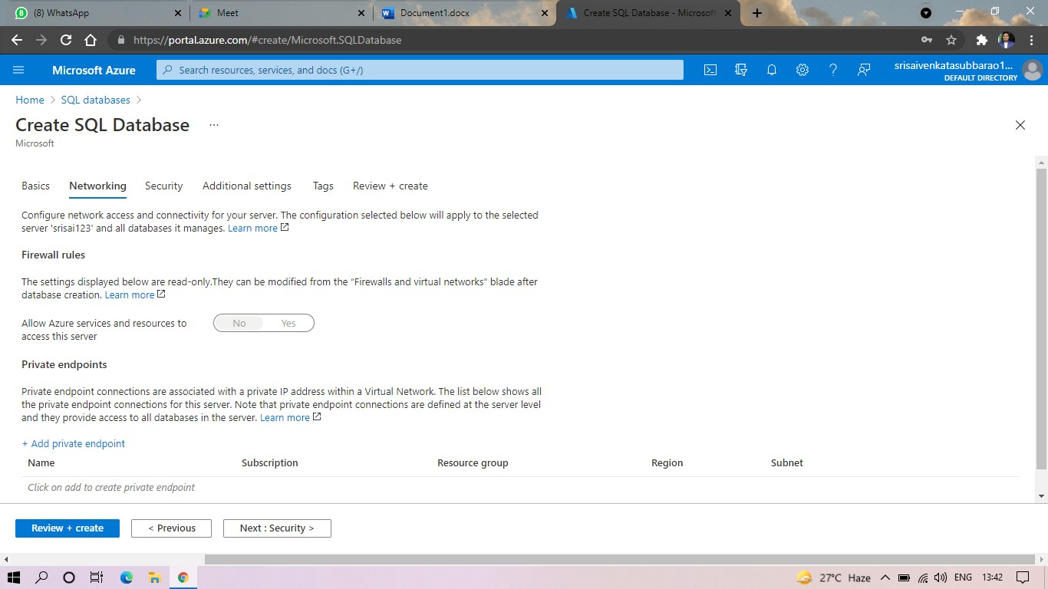

# STEP5: IN ADDITIONAL SETTINGS SELECT SAMPLE.

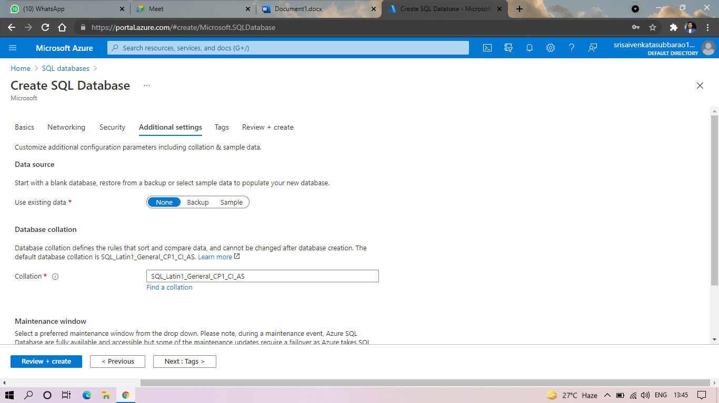

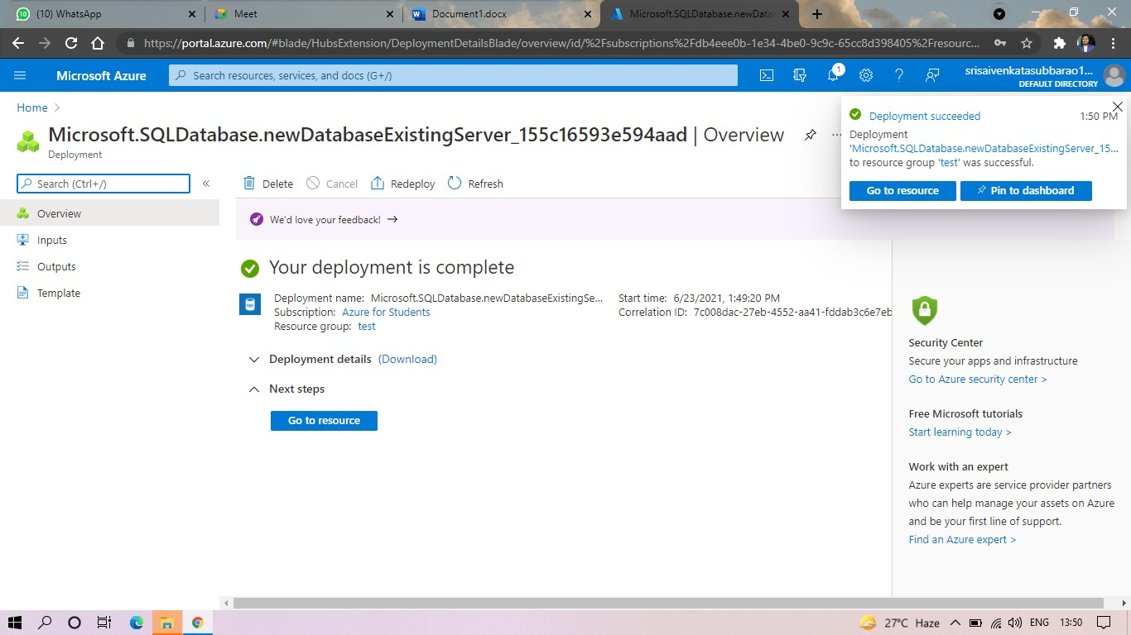**STEP6:AND THE SQL DATABASE IS DEPLOYED.**

# STEP7:AND NOW GOTO QUERY EDITOR.

**STEP8:AND NOW AGAIN LOGIN TO THE SQLDATADATABASE**

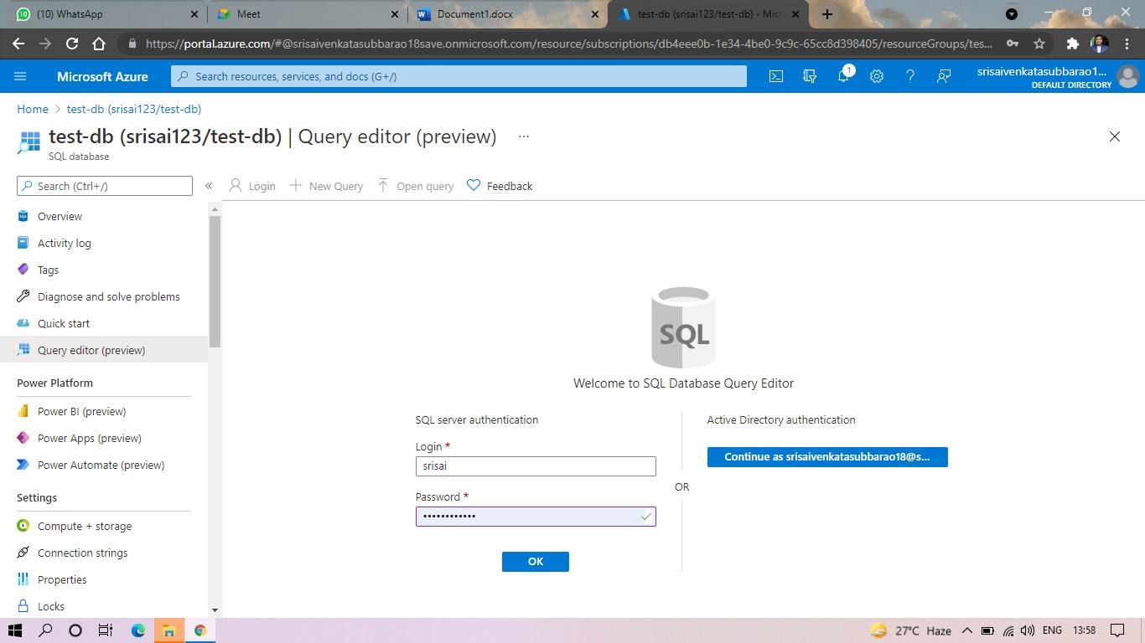

# STEP: AND OUR TABLES WILL SHOWN AND TYPE THE QUERY TO EXCUTED.

**STEP10: AND OUR OUTPUT IS READY.**

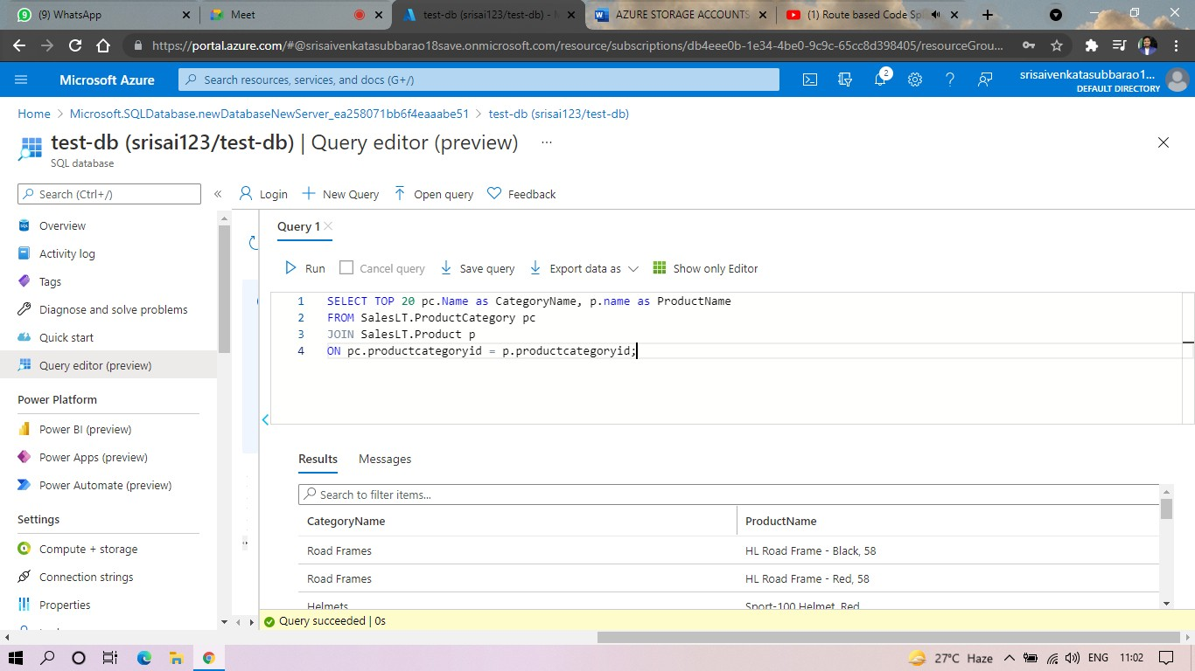

**RESULT:**

**EXP. 9: PERFORM THE BASIC CONFIGURATION SETUP FOR INSTALLING HADOOP 2.X LIKE CREATING THE HDUSER AND SSH LOCALHOST**

**AIM:**

**PROCEDURE:**

**Step 1** – System Update

$ sudo apt-get update

**Step 2** – Install Java and Set JAVA_HOME

//This first thing to do is to setup the webupd8 ppa on your system. Run the following command and proceed.

$ sudo apt-add-repository ppa:webupd8team/java

$ sudo apt-get update

//After setting up the ppa repository, update the package cache as well.

//Install the Java 8 installer

$ sudo apt-get install oracle-java8-installer

// After the installation is finished, Oracle Java is setup. Run the java command again to check the version and vendor.

[or]

$ sudo apt-get install default-jdk

$ java -version

**Step 3** – Add a dedicated Hadoop user

$ sudo addgroup hadoop

$ sudo adduser --ingroup hadoop hduser

// Add hduser to sudo user group

$ sudo adduser hduser sudo

**Step 4** – Install SSH and Create Certificates

$ sudo apt-get install ssh

$ su hduser

$ ssh-keygen -t rsa -P ""

// Set Environmental variables

$ cat $HOME/.ssh/id_rsa.pub >> $HOME/.ssh/authorized_keys

**Step 5** – Check if SSH works

$ ssh localhost

**Step 6** – Install Hadoop

// Extract Hadoop-2.7.2

$ sudo tar xvzf hadoop-2.7.2.tar.gz

// Create a folder ‘hadoop’ in /usr/local

$ sudo mkdir –p /usr/local/hadoop

// Move the Hadoop folder to /usr/local/hadoop

$ sudo mv hadoop-2.7.2 /usr/local/hadoop

// Assigning read and write access to Hadoop folder

$ sudo chown –R hduser:hadoop /usr/local/hadoop

**Implementation:**

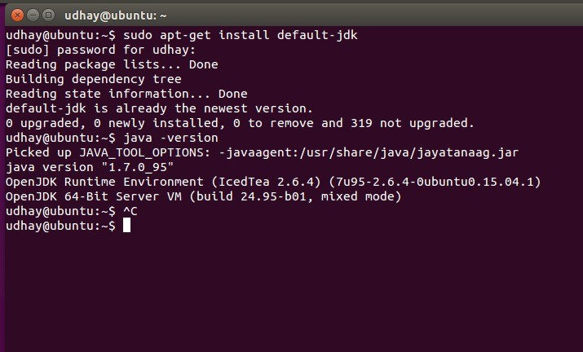

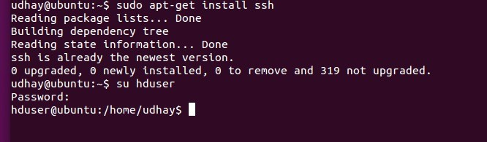

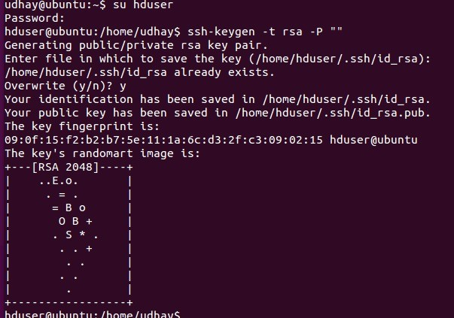

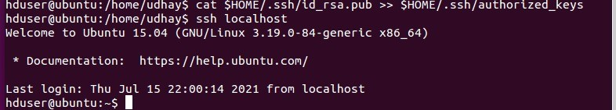

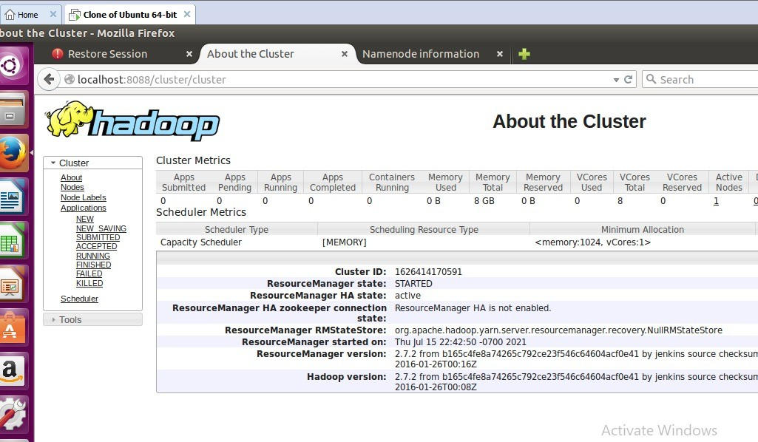

**RESULT:**

**EXP. 10: INSTALL HADOOP 2.X AND CONFIGURE THE NAME NODE AND DATA NODE.**

**AIM:**

**PROCEDURE:**

**Step 7** - Modify Hadoop config files

//Hadoop Environmental variable setting – The following files will be modified

* 1. ~/.bashrc
  2. /usr/local/hadoop/hadoop-2.7.2/etc/hadoop/hadoop-env.sh
  3. /usr/local/hadoop/hadoop-2.7.2/etc/hadoop/core-site.xml
  4. /usr/local/hadoop/hadoop-2.7.2/etc/hadoop/hdfs-site.xml
  5. /usr/local/hadoop/hadoop-2.7.2/etc/hadoop/yarn-site.xml
  6. /usr/local/hadoop/hadoop-2.7.2/etc/hadoop/mapred-site.xml.template

$ sudo nano ~/.bashrc

// Add the following lines at the end of the file

export JAVA_HOME=/usr/lib/jvm/java-8-oracle

export HADOOP_HOME=/usr/local/hadoop/hadoop-2.7.2 export PATH=$PATH:$HADOOP_HOME/bin

export PATH=$PATH:$HADOOP_HOME/sbin

export HADOOP_MAPRED_HOME=$HADOOP_HOME export HADOOP_COMMON_HOME=$HADOOP_HOME export HADOOP_HDFS_HOME=$HADOOP_HOME

export YARN_HOME=$HADOOP_HOME HADOOP_COMMON_LIB_NATIVE_DIR=$HADOOP_HOME/lib/native export HADOOP_OPTS="-D.java.library.path=$HADOOP_HOME/lib" export PATH=$PATH:/usr/local/hadoop/hadoop-2.7.2/bin

// Configure Hadoop Files

$ cd /usr/local/hadoop/hadoop-2.7.2/etc/hadoop/

$ sudo nano hadoop-env.sh

// Add following line in hadoop-env.sh – Set JAVA variable in Hadoop

# The java implementation to use.

export JAVA_HOME=/usr/lib/jvm/java-8-oracle

// Create datanode and namenode

$ sudo mkdir –p /usr/local/hadoop_tmp/hdfs/namenode

$ sudo mkdir –p /usr/local/hadoop_tmp/hdfs/datanode

// Changing ownership to hadoop_tmp

$ sudo chown –R hduser:hadoop /usr/local/hadoop_tmp

// Edit hdfs-site.xml

$ sudo nano hdfs-site.xml

// Add the following lines between <configuration> …… </configuration>

<configuration>

<property>

<name>dfs.replication</name>

<value>1</value>

</property>

<property>

<name>dfs.namenode.name.dir</name>

<value>file:/usr/local/hadoop_tmp/hdfs/namenode</value>

</property>

<property>

<name>dfs.datanode.data.dir</name>

<value>file:/usr/local/hadoop_tmp/hdfs/datanode</value>

</property>

</configuration>

// Edit core-site.xml

$ sudo nano core-site.xml

// Add the following lines between <configuration> …… </configuration>

<configuration>

<property>

<name>fs.default.name</name>

<value>hdfs://localhost:9000</value>

</property>

</configuration>

// Edit yarn-site.xml

$ sudo nano yarn-site.xml

// Add the following lines between <configuration> …… </configuration>

<configuration>

<property>

<name>yarn.nodemanager.aux-services</name>

<value>mapreduce_shuffle</value>

</property>

<property>

<name>yarn.nodemanager.aux-services.mapreduce.shuffle.class</name>

<value>org.apache.hadoop.mapred.Shuffle-Handler</value>

</property>

</configuration>

// Edit mapred-site.xmsudo

$ cp /usr/local/hadoop/hadoop-2.7.2/etc/hadoop/mapred-site.xml.template

/usr/local/hadoop/hadoop-2.7.2/etc/hadoop/mapred-site.xml

$ sudo nano mapred-site.xml

// Add the following lines between <configuration> …… </configuration>

<configuration>

<property>

<name>mapreduce.framework.name</name>

<value>yarn</value>

</property>

</configuration>

**Step-8** – Format Hadoop File System

$ cd /usr/local/hadoop/hadoop-2.7.2/bin

$ hadoop namenode -format

**Step 9** - Start Hadoop

$ cd /usr/local/hadoop/hadoop-2.7.2/sbin

// Starting dfs services

$ start-dfs.sh

// Starting mapreduce services

$ start-yarn.sh

$ jps

**Step 10** - Check Hadoop through web UI

Go to browser type http://localhost:8088 – All Applications Hadoop Cluster Go to browser type http://localhost:50070 – Hadoop Namenode

**Step 11** - Stop Hadoop

$ stop-dfs.sh

$ stop-yarn.sh

**IMPLEMENTAION:**

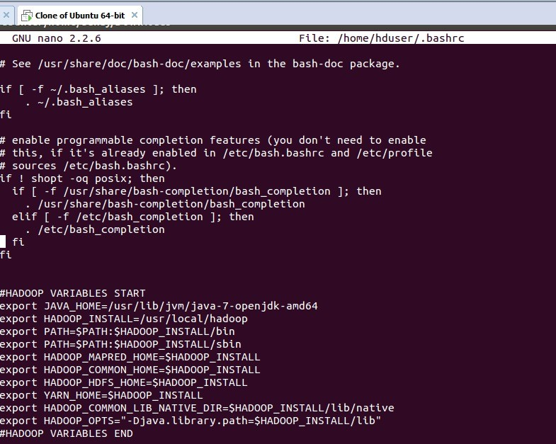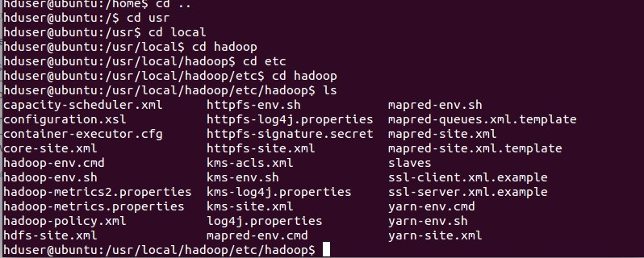

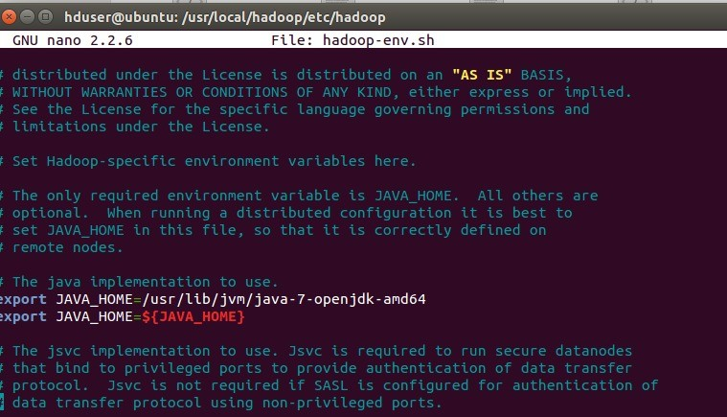

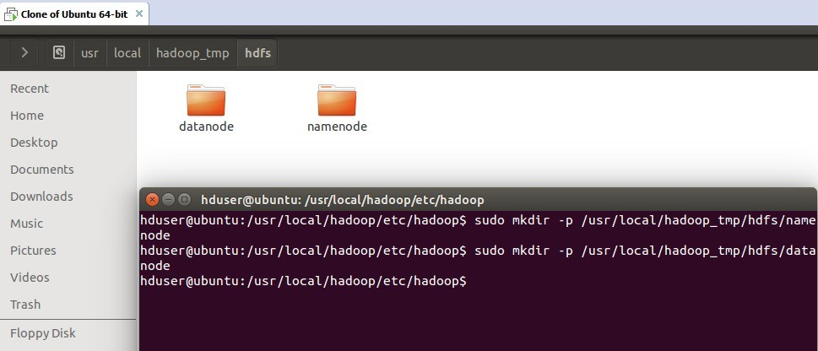

**RESULT:**

**EXP. 11 LAUNCH THE HADOOP 2.X AND PERFORM MAPREDUCE PROGRAM FOR A WORD COUNT PROBLEM**

**AIM:**

**PROCEDURE:**

**Step 1 - Open Terminal**

$ su hduser Password:

**Step 2 - Start dfs and mapreduce services**

$ cd /usr/local/hadoop/hadoop-2.7.2/sbin

$ start-dfs.sh

$ start-yarn.sh

$ jps

**Step 3 - Check Hadoop through web UI**

// Go to browser type http://localhost:8088 – All Applications Hadoop Cluster

// Go to browser type http://localhost:50070 – Hadoop Namenode

**Step 4 – Open New Terminal**

$ cd Desktop/

$ mkdir inputdata

$ cd inputdata/

$ echo “Hai, Hello, How are you? How is your health?” >> hello.txt

$ cat >> hello.txt

**Step 5 – Go back to old Terminal**

$ hadoop fs –copyFromLocal /home/hduser/Desktop/inputdata/hello.txt /folder/hduser

// Check in hello.txt in Namenode using Web UI

**Step 6 – Download and open eclipse by creating workspace**

Create a new java project.

**Step 7 – Add jar to the project**

You need to remove dependencies by adding jar files in the hadoop source folder. Now Click on **Project** tab and go to Properties.Under Libraries tab, click Add External JARs and select all the

jars in the folder (click on 1st jar, and Press Shift and Click on last jat to select all jars in between and click ok)

**/usr/local/hadoop/hadoop-2.7.2/share/hadoop/common**and

**/usr/local/hadoop/hadoop-2.7.2/share/hadoop/mapreduce** folders.

**Step -8 – WordCount Program Create 3 java files named**

* **WordCount.java**
* **WordCountMapper.java**
* **WordCountReducer.java WordCount.java**

import org.apache.hadoop.conf.Configured; import org.apache.hadoop.fs.Path;

import org.apache.hadoop.io.IntWritable;

import org.apache.hadoop.mapred.FileInputFormat; import org.apache.hadoop.mapred.FileOutputFormat; import org.apache.hadoop.mapred.JobClient;

import org.apache.hadoop.mapred.JobConf;

import org.apache.hadoop.util.Tool;

import org.apache.hadoop.util.ToolRunner; import org.apache.hadoop.io.Text;

public class WordCount extends Configured implements Tool { @Override

public int run(String[] arg0) throws Exception {

// TODO Auto-generated method stub if(arg0.length<2)

{

System.out.println("check the command line arguments");

}

JobConf conf=new JobConf(WordCount.class); FileInputFormat.setInputPaths(conf, new Path(arg0[0]));

FileOutputFormat.setOutputPath(conf, new Path(arg0[1])); conf.setMapperClass(WordMapper.class); conf.setReducerClass(WordReducer.class); conf.setOutputKeyClass(Text.class); conf.setOutputValueClass(IntWritable.class); conf.setOutputKeyClass(Text.class); conf.setOutputValueClass(IntWritable.class); JobClient.runJob(conf);

return 0;

}

public static void main(String args[]) throws Exception

{

int exitcode=ToolRunner.run(new WordCount(), args); System.exit(exitcode);

}

}

**WordCountMapper.java**

import java.io.IOException;

import org.apache.hadoop.io.IntWritable; import org.apache.hadoop.io.LongWritable;

import org.apache.hadoop.mapred.MapReduceBase; import org.apache.hadoop.mapred.OutputCollector; import org.apache.hadoop.mapred.Reporter;

import org.apache.hadoop.io.Text;

import org.apache.hadoop.mapred.Mapper;

public class WordCountMapper extends MapReduceBase implements Mapper<LongWritable,Text,Text,IntWritable>

{

@Override

public void map(LongWritable arg0, Text arg1, OutputCollector<Text, IntWritable> arg2, Reporter arg3)

throws IOException {

// TODO Auto-generated method stub

String s=arg1.toString(); for(String word:s.split(" "))

{

arg2.collect(new Text(word),new IntWritable(1));

}

}

}

**WordCountReducer.java**

import java.io.IOException; import java.util.Iterator;

import org.apache.hadoop.io.IntWritable; import org.apache.hadoop.mapred.JobConf;

import org.apache.hadoop.mapred.OutputCollector; import org.apache.hadoop.mapred.Reducer;

import org.apache.hadoop.mapred.Reporter; import org.apache.hadoop.io.Text;

public class WordCountReducer implements Reducer<Text,IntWritable,Text,IntWritable> { @Override

public void configure(JobConf arg0) {

// TODO Auto-generated method stub

}

@Override

public void close() throws IOException {

// TODO Auto-generated method stub

}

@Override

public void reduce(Text arg0, Iterator<IntWritable> arg1, OutputCollector<Text, IntWritable> arg2, Reporter arg3)

throws IOException {

// TODO Auto-generated method stub int count=0;

while(arg1.hasNext())

{

IntWritable i=arg1.next(); count+=i.get();

}

arg2.collect(arg0,new IntWritable(count));

}

}

**Step 9 - Creatr JAR file**

Now Click on the Run tab and click Run-Configurations. Click on New Configuration button on the left-top side and Apply after filling the following properties.

**Step 10 - Export JAR file**

Now click on File tab and select Export. under Java, select Runnable Jar.

In Launch Config – select the config fie you created in **Step 9** (WordCountConfig).

Select an export destination (lets say desktop.)

Under Library handling, select Extract Required Libraries into generated JAR and click Finish.

Right-Click the jar file, go to Properties and under **Permissions**tab, Check Allow executing file as a program. and give Read and Write access to all the users

**Step 11 – Go back to old Terminal for Execution of WordCount Program**

**$hadoop jar** wordcount.jar**/**usr**/**local**/**hadoop**/**input**/**usr**/**local**/**hadoop**/**output

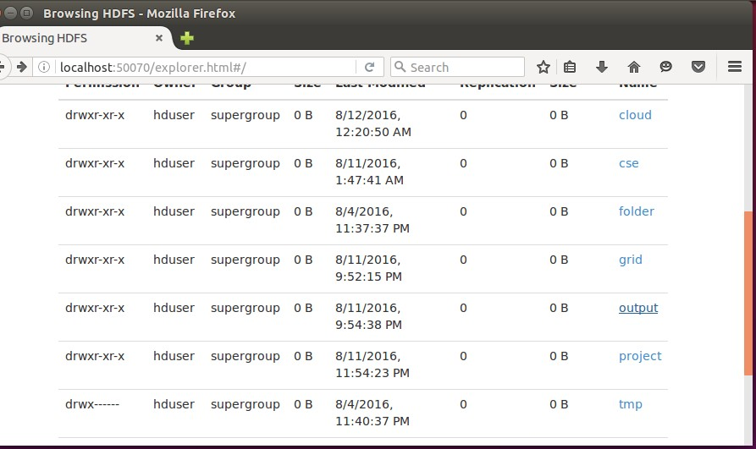

**Step 12 – To view results in old Terminal**

$**hdfs dfs -cat /usr/local/hadoop/output/part-r-00000**

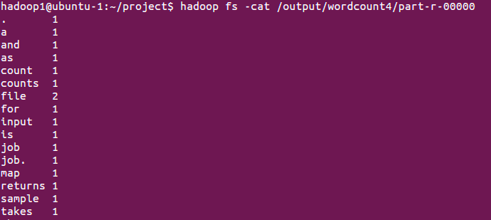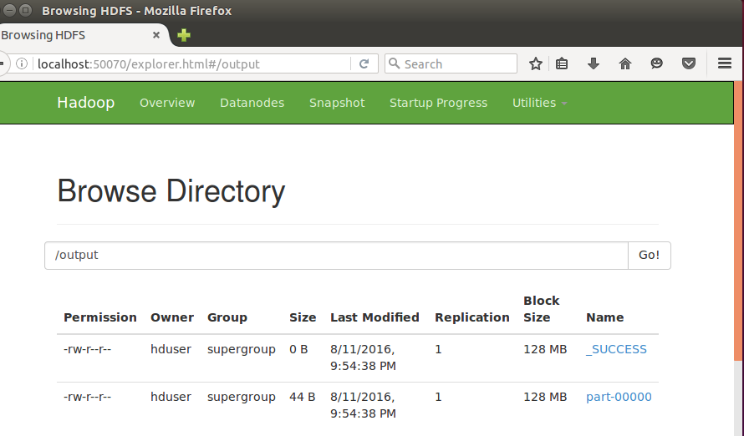

**Step 13 - To Remove folders created using hdfs**

**$ hdfs dfs -rm -R /usr/local/hadoop/output**

**RESULT:**